**Table of Contents**

1. Introduction 2

1.1. Aim 2

1.2. Objectives 2

2. User Interface Design 3

2.1. Wireframe 3

2.2. Actual design 11

3. Class diagram 21

4. Method Description 22

5. Test cases 26

5.1. Register user 26

5.2. Login to the website 28

5.3. Add product in product page by admin 31

5.4. Delete Product ID 33

5.5. Update Product ID 35

5.6. Search by Category 37

5.7. Add to cart 39

5.8. Password Encryption 40

6. Tools and libraries 41

7. Development Process 43

8. Critical Analysis 45

9. Conclusion 46

10. Bibliography 47

**Table of Figures**

[Figure 1: Wireframe of Login page 3](https://d.docs.live.net/216a446fa2e3fd93/AdvancedProgrammingandTechnologies_2a860253-44d0-4050-8c97-890361d22e03_93445_.docx#_Toc134436562)

[Figure 2: Wireframe of sign up page 4](https://d.docs.live.net/216a446fa2e3fd93/AdvancedProgrammingandTechnologies_2a860253-44d0-4050-8c97-890361d22e03_93445_.docx#_Toc134436563)

Figure 3: Wireframe of the home page 5

[Figure 4: Wireframe of product page 6](https://d.docs.live.net/216a446fa2e3fd93/AdvancedProgrammingandTechnologies_2a860253-44d0-4050-8c97-890361d22e03_93445_.docx#_Toc134436565)

Figure 5: Wireframe of contact us page 7

[Figure 6 Wireframe to delete product and looking product details 8](https://d.docs.live.net/216a446fa2e3fd93/AdvancedProgrammingandTechnologies_2a860253-44d0-4050-8c97-890361d22e03_93445_.docx#_Toc134436567)

[Figure 7 Wireframe to add product 8](https://d.docs.live.net/216a446fa2e3fd93/AdvancedProgrammingandTechnologies_2a860253-44d0-4050-8c97-890361d22e03_93445_.docx#_Toc134436568)

Figure 8 Wireframe for Update product 9

Figure 9 Wireframe of cart 10

[Figure 10 Actual design 11](https://d.docs.live.net/216a446fa2e3fd93/AdvancedProgrammingandTechnologies_2a860253-44d0-4050-8c97-890361d22e03_93445_.docx#_Toc134436571)

[Figure 11 Actual Design of create account 11](https://d.docs.live.net/216a446fa2e3fd93/AdvancedProgrammingandTechnologies_2a860253-44d0-4050-8c97-890361d22e03_93445_.docx#_Toc134436572)

Figure 12 Actual design of Update product 12

Figure 13: Product Page 12

Figure 14: Contact Us page 13

Figure 15: Contact-Us page 13

Figure 16: Contact-Us 14

Figure 17: Actual Design of add Product 15

[Figure 18 Delete product 15](https://d.docs.live.net/216a446fa2e3fd93/AdvancedProgrammingandTechnologies_2a860253-44d0-4050-8c97-890361d22e03_93445_.docx#_Toc134436579)

Figure 19: Show Product-Detail 16

Figure 20: Update Product 16

Figure 21: Home Page 17

Figure 22: Home Page 17

Figure 23: Home Page 18

Figure 24: Home Page 18

Figure 25: Home Page 19

Figure 26: Home Page 19

Figure 27: Cart Page 20

Figure 28: Class Diagram 21

[Figure 29: Register UI 27](https://d.docs.live.net/216a446fa2e3fd93/AdvancedProgrammingandTechnologies_2a860253-44d0-4050-8c97-890361d22e03_93445_.docx#_Toc134436590)

Figure 30: Login Page 29

Figure 31: After logged in interface 30

[Figure 32: Add to prodcut form 31](https://d.docs.live.net/216a446fa2e3fd93/AdvancedProgrammingandTechnologies_2a860253-44d0-4050-8c97-890361d22e03_93445_.docx#_Toc134436593)

[Figure 33: Add to product Form 31](https://d.docs.live.net/216a446fa2e3fd93/AdvancedProgrammingandTechnologies_2a860253-44d0-4050-8c97-890361d22e03_93445_.docx#_Toc134436594)

[Figure 34:Store the product details which are added 32](https://d.docs.live.net/216a446fa2e3fd93/AdvancedProgrammingandTechnologies_2a860253-44d0-4050-8c97-890361d22e03_93445_.docx#_Toc134436595)

[Figure 35: Product inserted 32](https://d.docs.live.net/216a446fa2e3fd93/AdvancedProgrammingandTechnologies_2a860253-44d0-4050-8c97-890361d22e03_93445_.docx#_Toc134436596)

[Figure 36: Entered product ID to delete 33](https://d.docs.live.net/216a446fa2e3fd93/AdvancedProgrammingandTechnologies_2a860253-44d0-4050-8c97-890361d22e03_93445_.docx#_Toc134436597)

[Figure 37: List of product 33](https://d.docs.live.net/216a446fa2e3fd93/AdvancedProgrammingandTechnologies_2a860253-44d0-4050-8c97-890361d22e03_93445_.docx#_Toc134436598)

[Figure 38: Product deleted 34](https://d.docs.live.net/216a446fa2e3fd93/AdvancedProgrammingandTechnologies_2a860253-44d0-4050-8c97-890361d22e03_93445_.docx#_Toc134436599)

[Figure 39: List of products with their details 35](https://d.docs.live.net/216a446fa2e3fd93/AdvancedProgrammingandTechnologies_2a860253-44d0-4050-8c97-890361d22e03_93445_.docx#_Toc134436600)

[Figure 40: Updating the Product 36](https://d.docs.live.net/216a446fa2e3fd93/AdvancedProgrammingandTechnologies_2a860253-44d0-4050-8c97-890361d22e03_93445_.docx#_Toc134436601)

[Figure 41: Finally product have been updated 36](https://d.docs.live.net/216a446fa2e3fd93/AdvancedProgrammingandTechnologies_2a860253-44d0-4050-8c97-890361d22e03_93445_.docx#_Toc134436602)

Figure42: Searching product by name 37

[Figure 43: List of shoes 38](https://d.docs.live.net/216a446fa2e3fd93/AdvancedProgrammingandTechnologies_2a860253-44d0-4050-8c97-890361d22e03_93445_.docx#_Toc134436604)

[Figure 44: Product page before adding to cart 39](https://d.docs.live.net/216a446fa2e3fd93/AdvancedProgrammingandTechnologies_2a860253-44d0-4050-8c97-890361d22e03_93445_.docx#_Toc134436605)

[Figure 45: Added Products in Card 40](https://d.docs.live.net/216a446fa2e3fd93/AdvancedProgrammingandTechnologies_2a860253-44d0-4050-8c97-890361d22e03_93445_.docx#_Toc134436606)

Figure 46: setting password during registration 41

Figure 47: Encrypted Password in Database 41

# Introduction

This coursework entails developing an e-commerce website selling clothes that adhere to the MVC pattern. The site must include a home page, product page, login page, signup page and contact us page. Registration requires users to upload an image and requires passwords to be encrypted. Sessions and cookies should be closed/distorted upon logout. Logged-in users can edit profiles, change passwords or add products to their cart admins can add edit delete products and view the product page or order list. The product page includes a search bar allowing users to filter results by categories, prices, and ratings users may view the homepage without logging in but require credentials to add items to the cart.

## Aim

This coursework aims to design and develop an E-commerce website that allows users to browse and purchase clothing items online, following the MVC pattern and best practices for web development.

## Objectives

The following is the objective of this coursework: -

* To implement the MVC pattern in the design and development of the E-commerce website, with distinct packages for the Model, View, and Controller components.
* To implement a user-friendly interface that allows customers to easily navigate the website, search for clothes and make purchases.
* Utilize secure encryption and authentication methods for safeguarding customer data.
* To incorporate a robust database system capable of storing and easily retrieving information about items, users, orders and transactions.
* To ensure effective collaboration as a group, with a clear division of tasks and responsibilities, communication and resolution of any conflicts or issues.

# User Interface Design

A user interface, commonly referred to as a “UI,” is the user-facing design of a webpage or application. User-friendly UI is important for ecommerce merchants to provide intuitive navigation and a pleasant shopping experience for customers.

## Wireframe

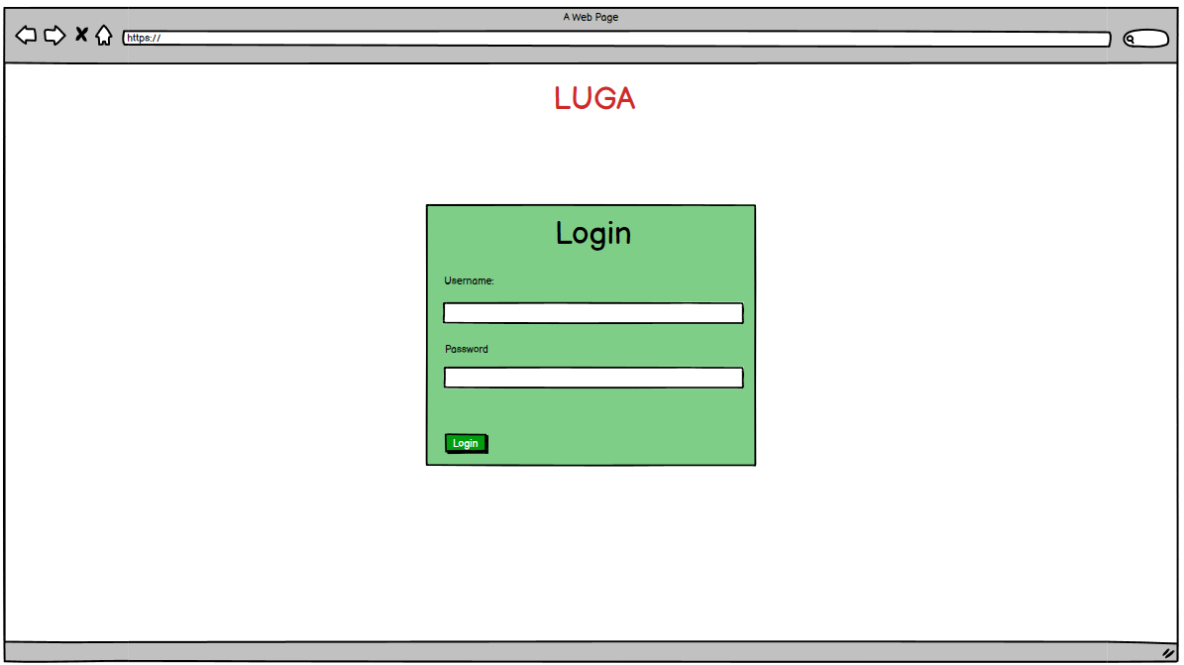

Figure 1: Wireframe of Login page

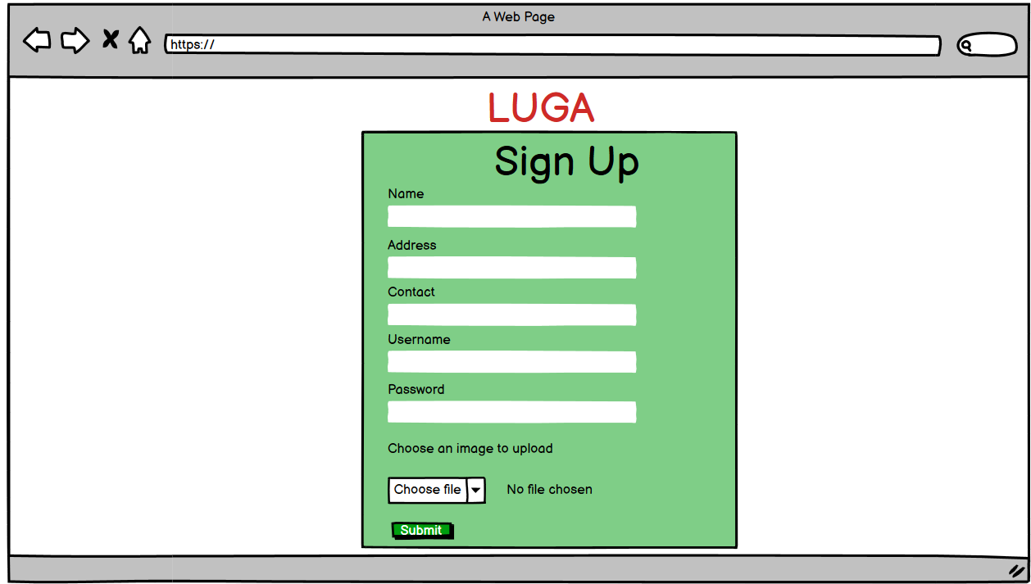

Figure 2: Wireframe of sign up page

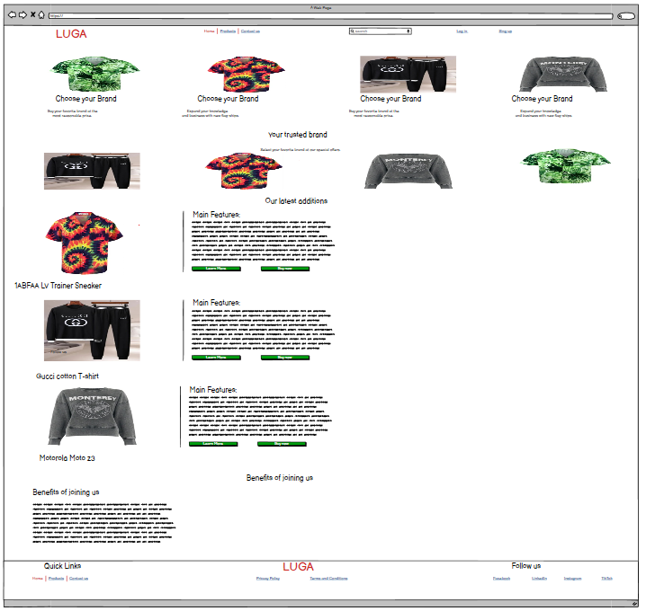

Figure 3: Wireframe of the home page

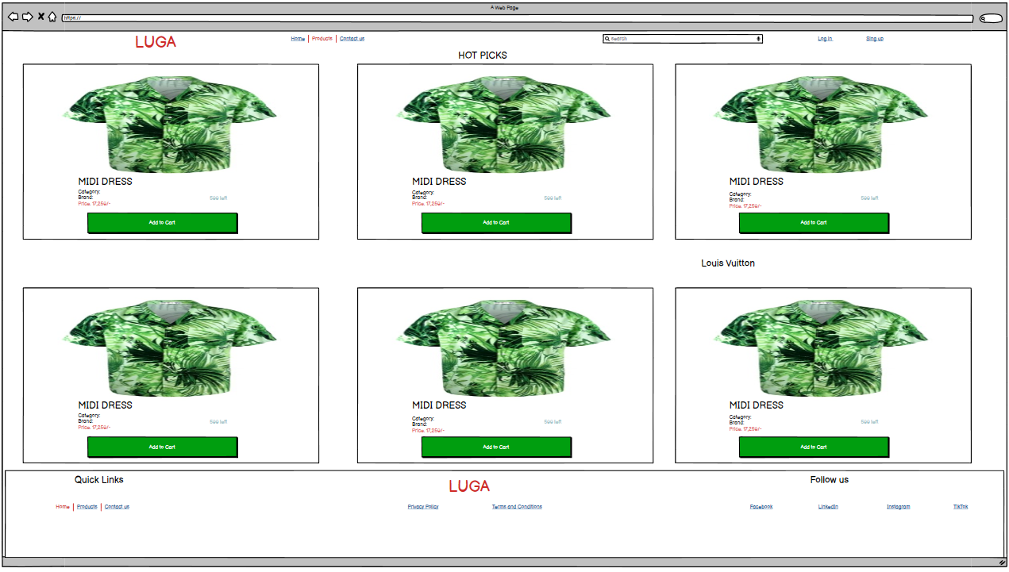

Figure 4: Wireframe of product page

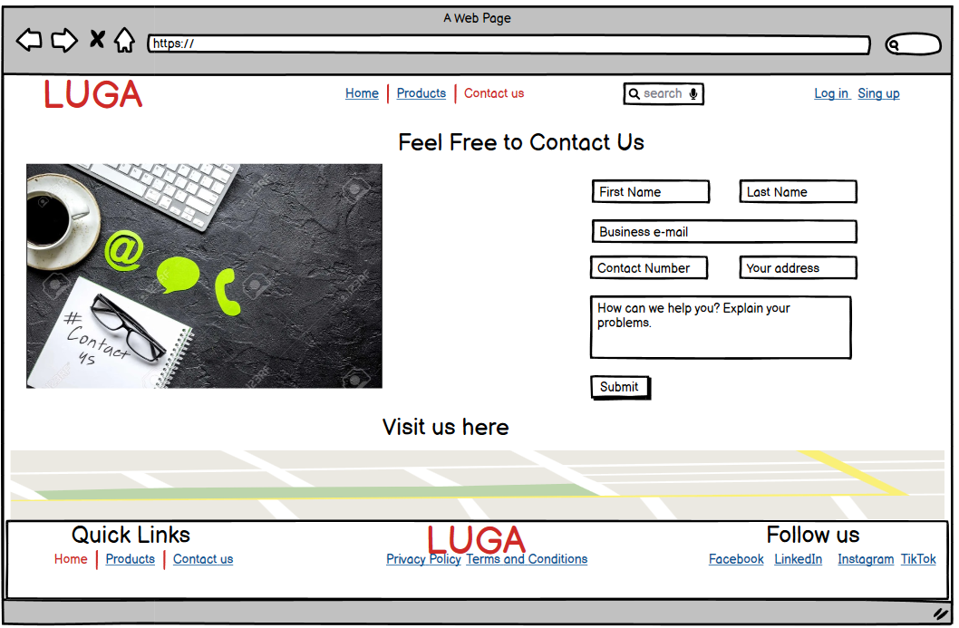

Figure 5: Wireframe of contact us page

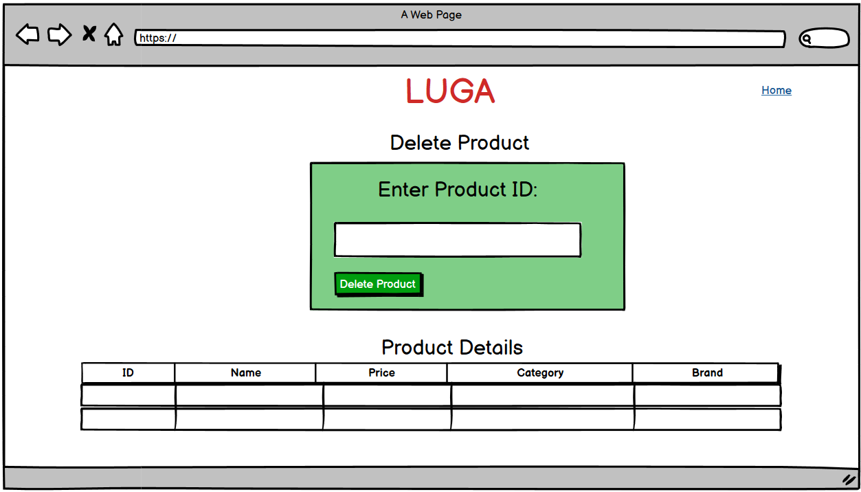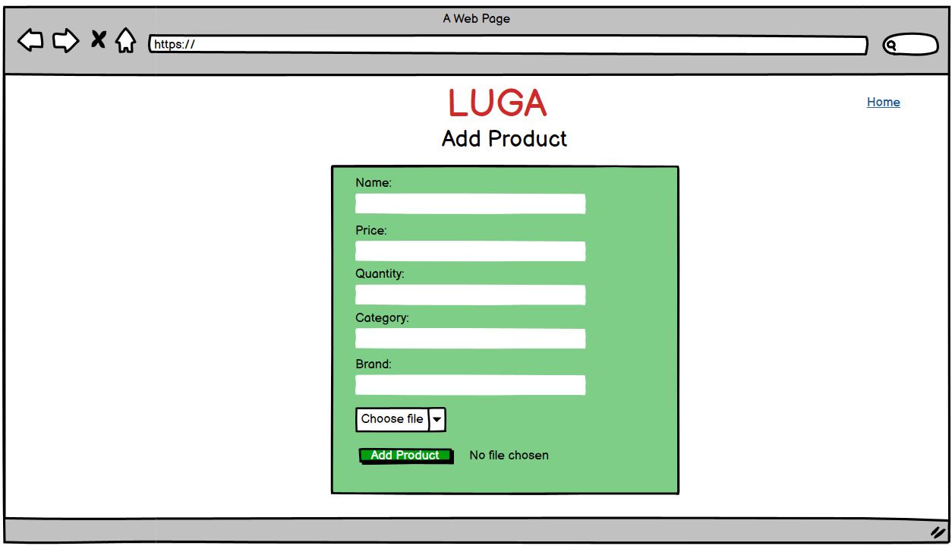

Figure 6 Wireframe to delete product and looking product details

Figure 7 Wireframe to add product

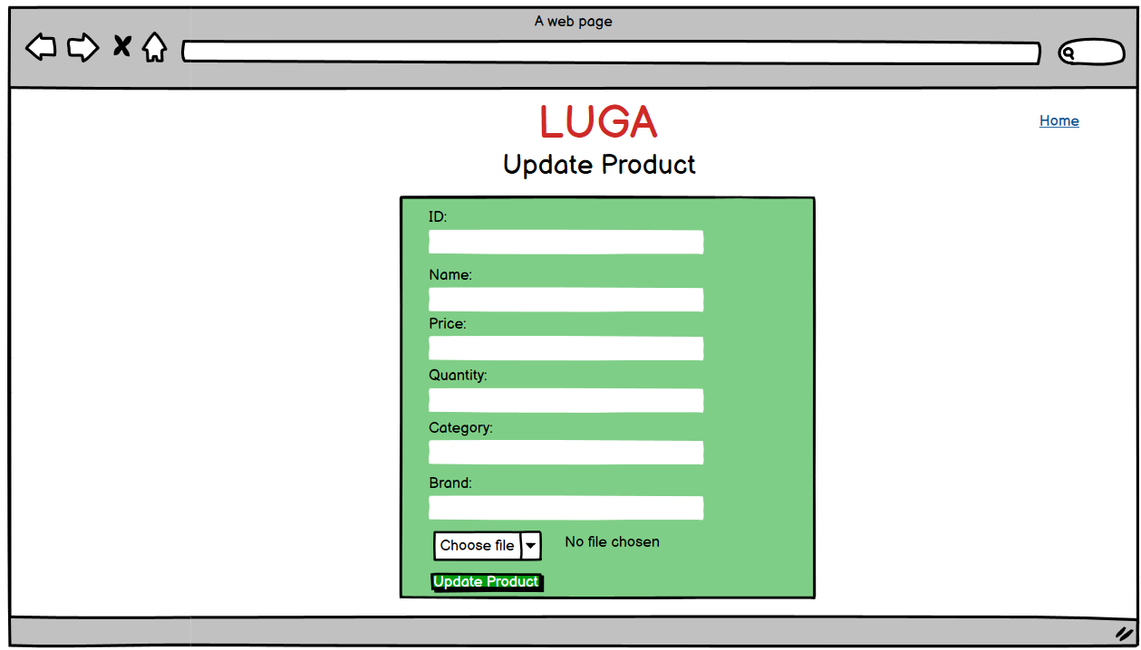

Figure 8 Wireframe for Update product

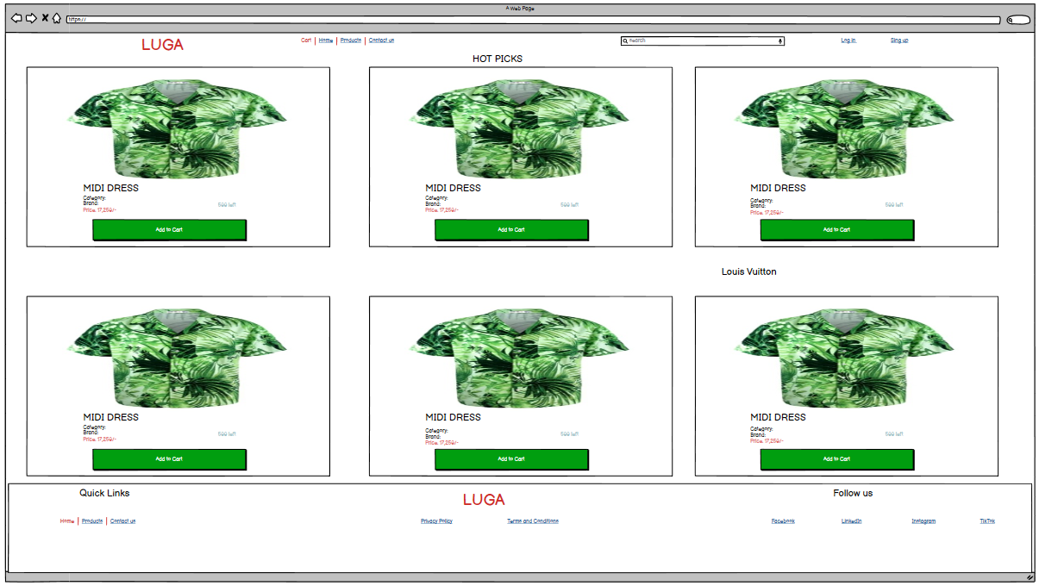

Figure 9 Wireframe of cart

## Actual design

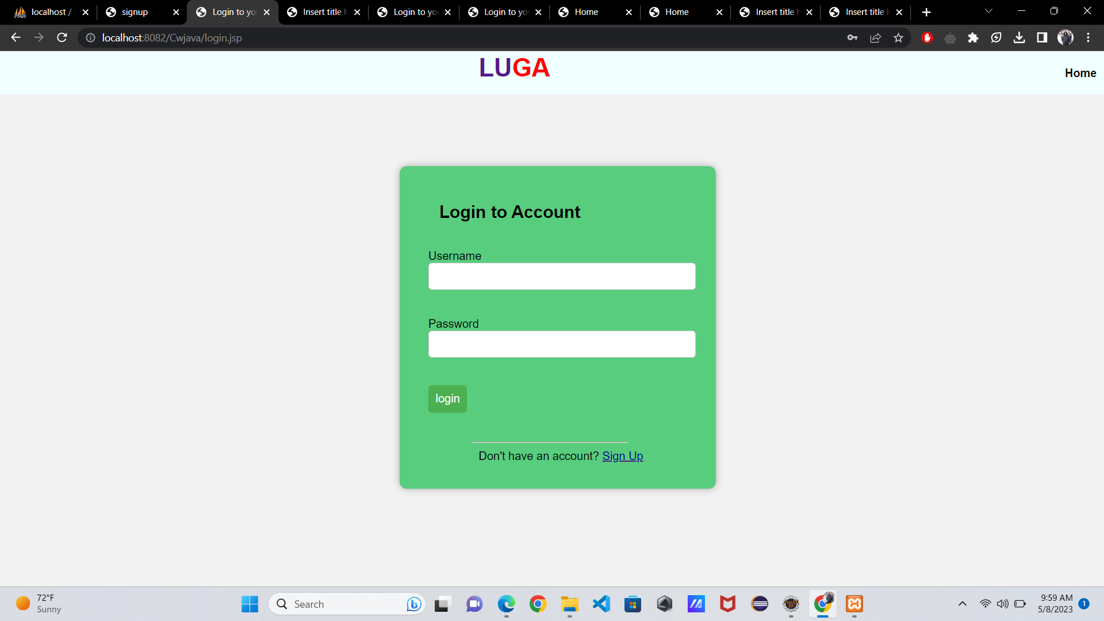

Figure 10 Actual design

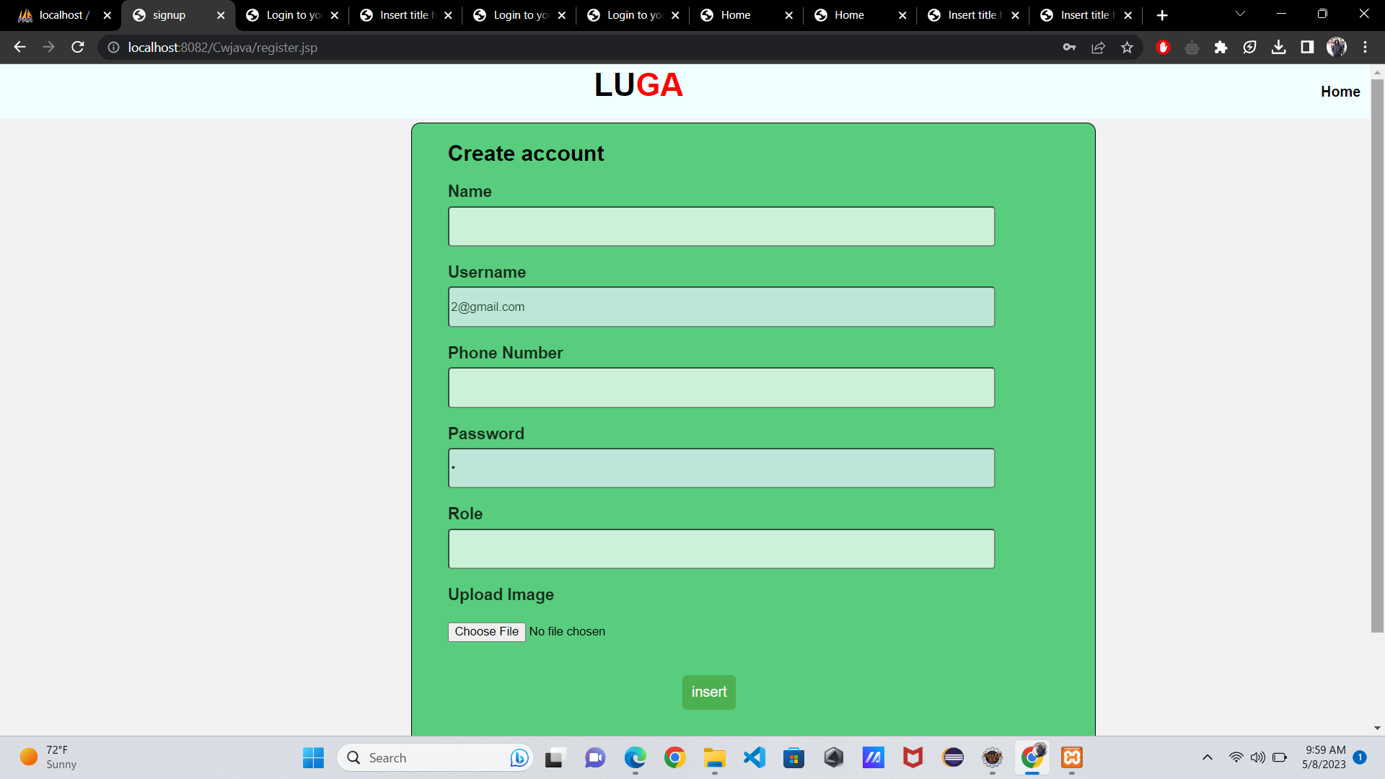

Figure 11 Actual Design of create account

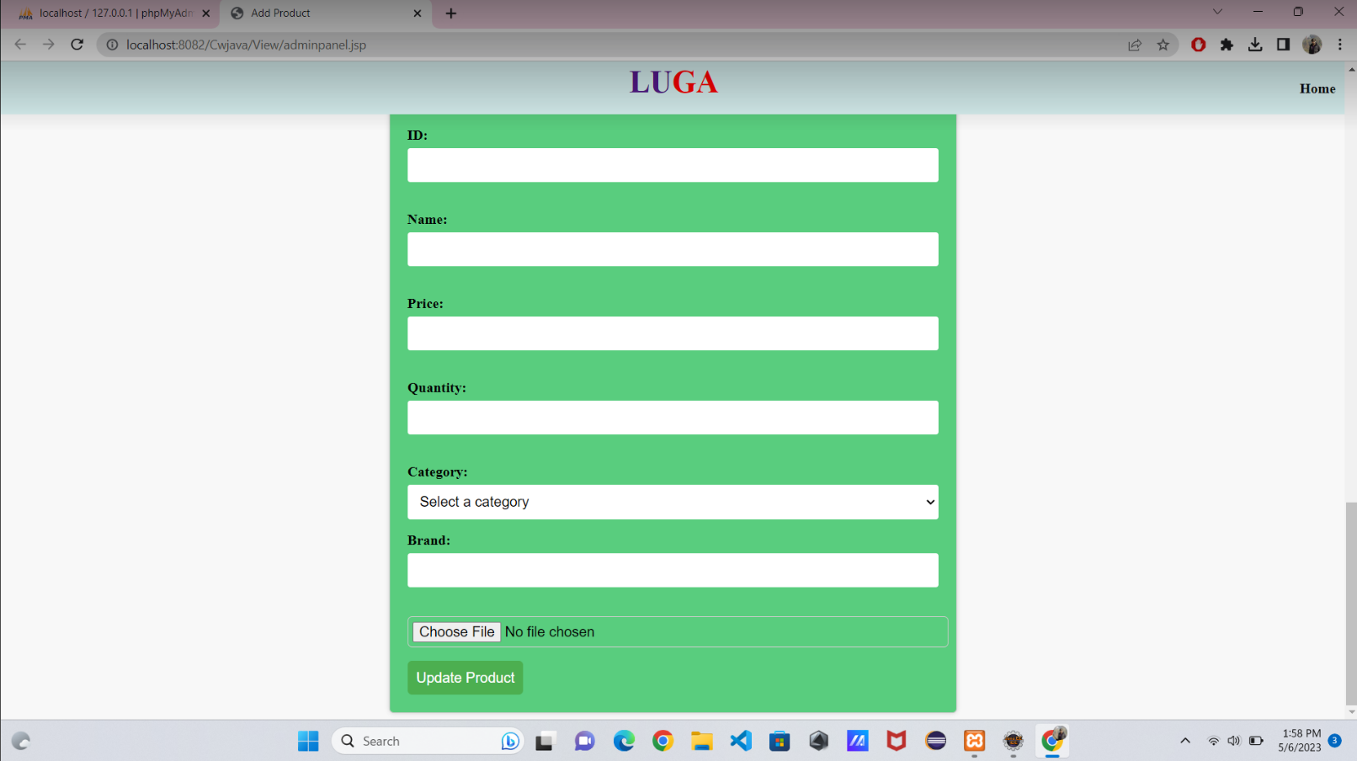

Figure 12 Actual design of Update product

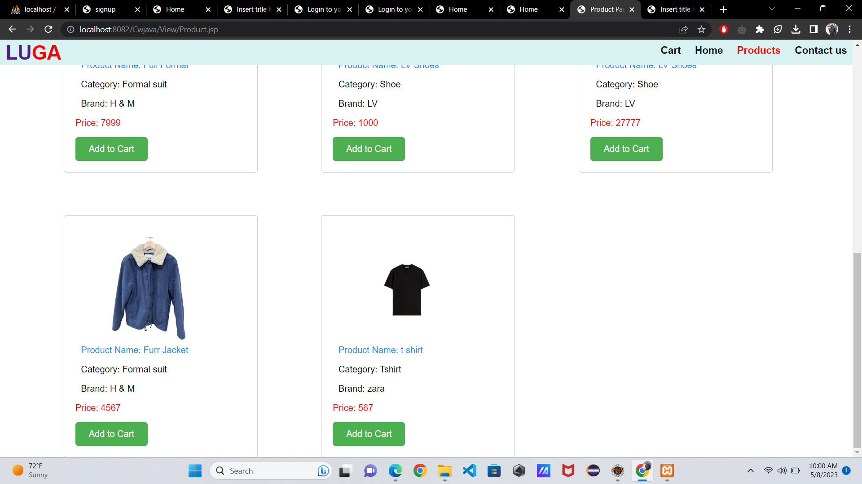

Figure 13: Product Page

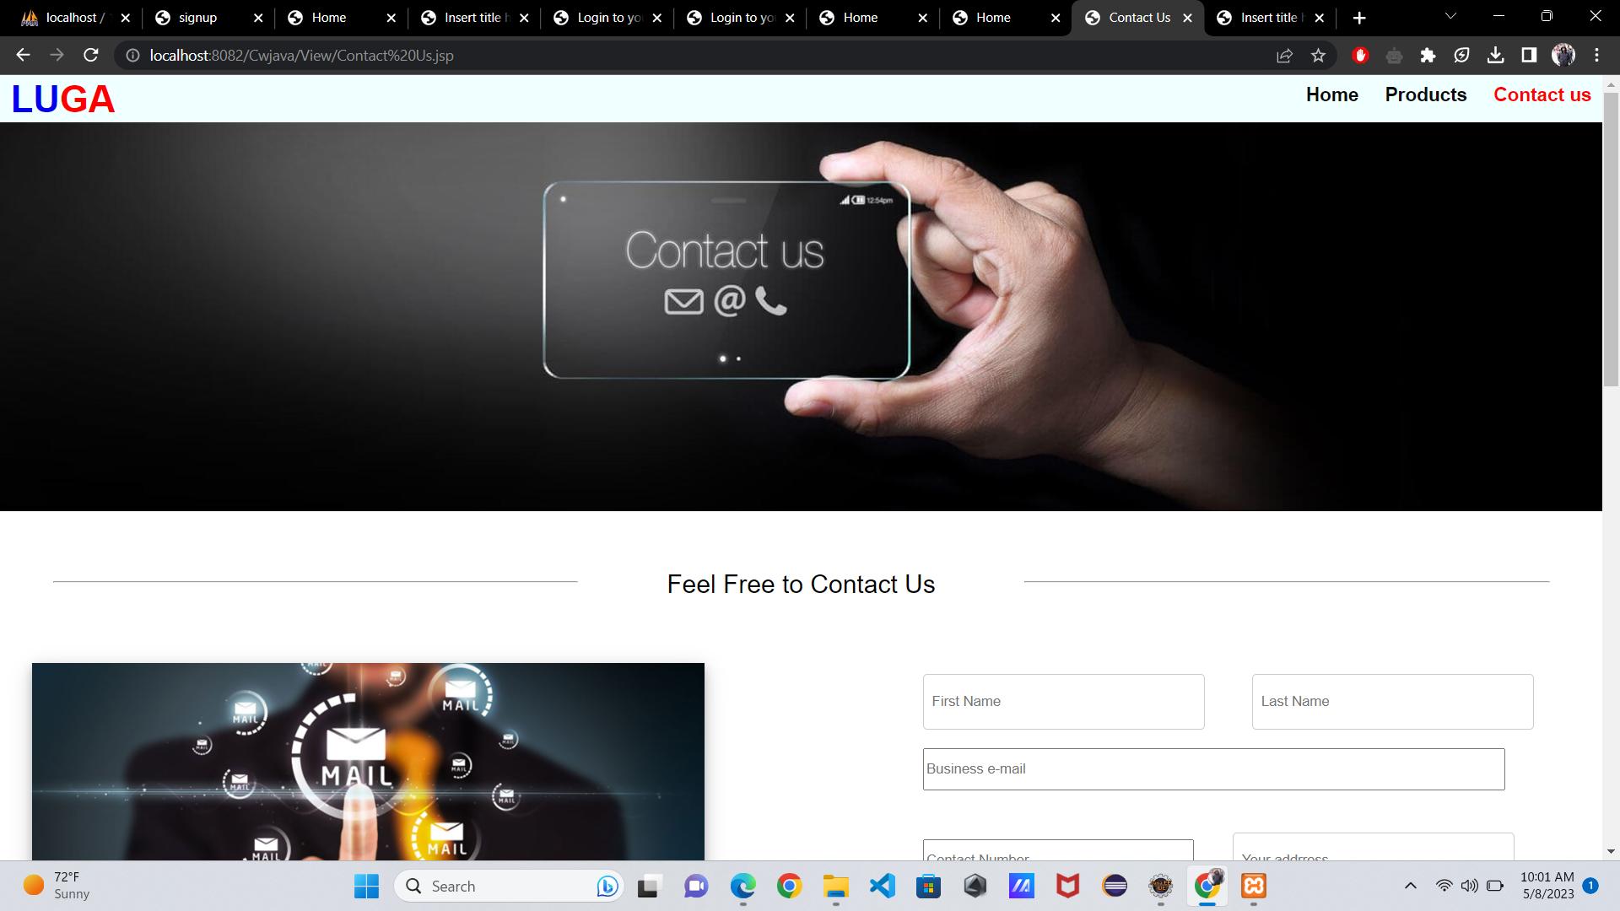

Figure 14: Contact Us page

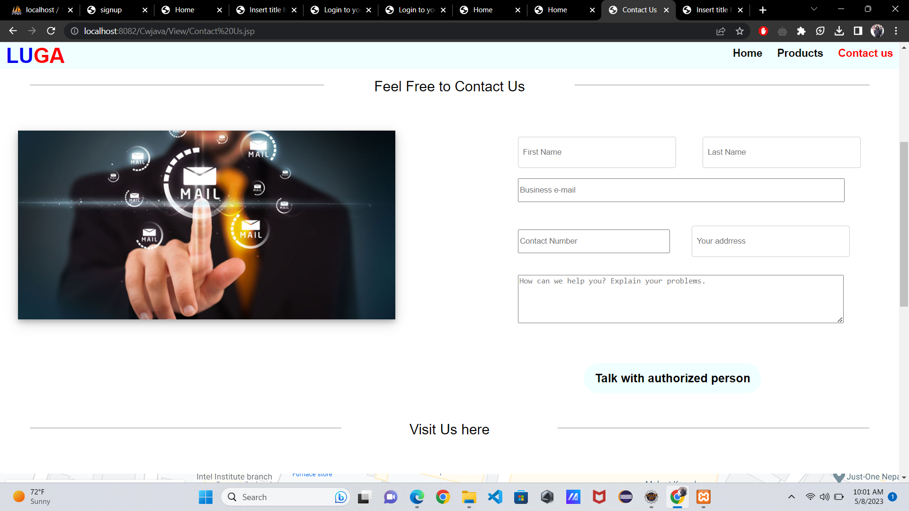

Figure 15: Contact-Us page

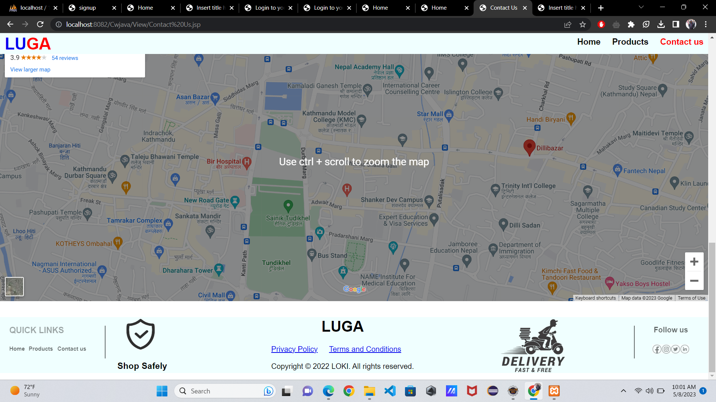

Figure 16: Contact-Us

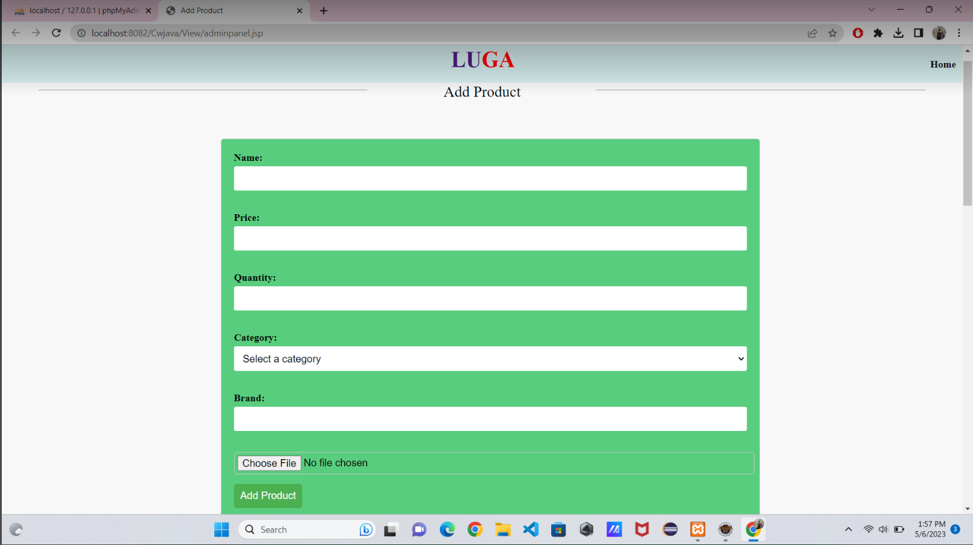

Figure 17: Actual Design of add Product

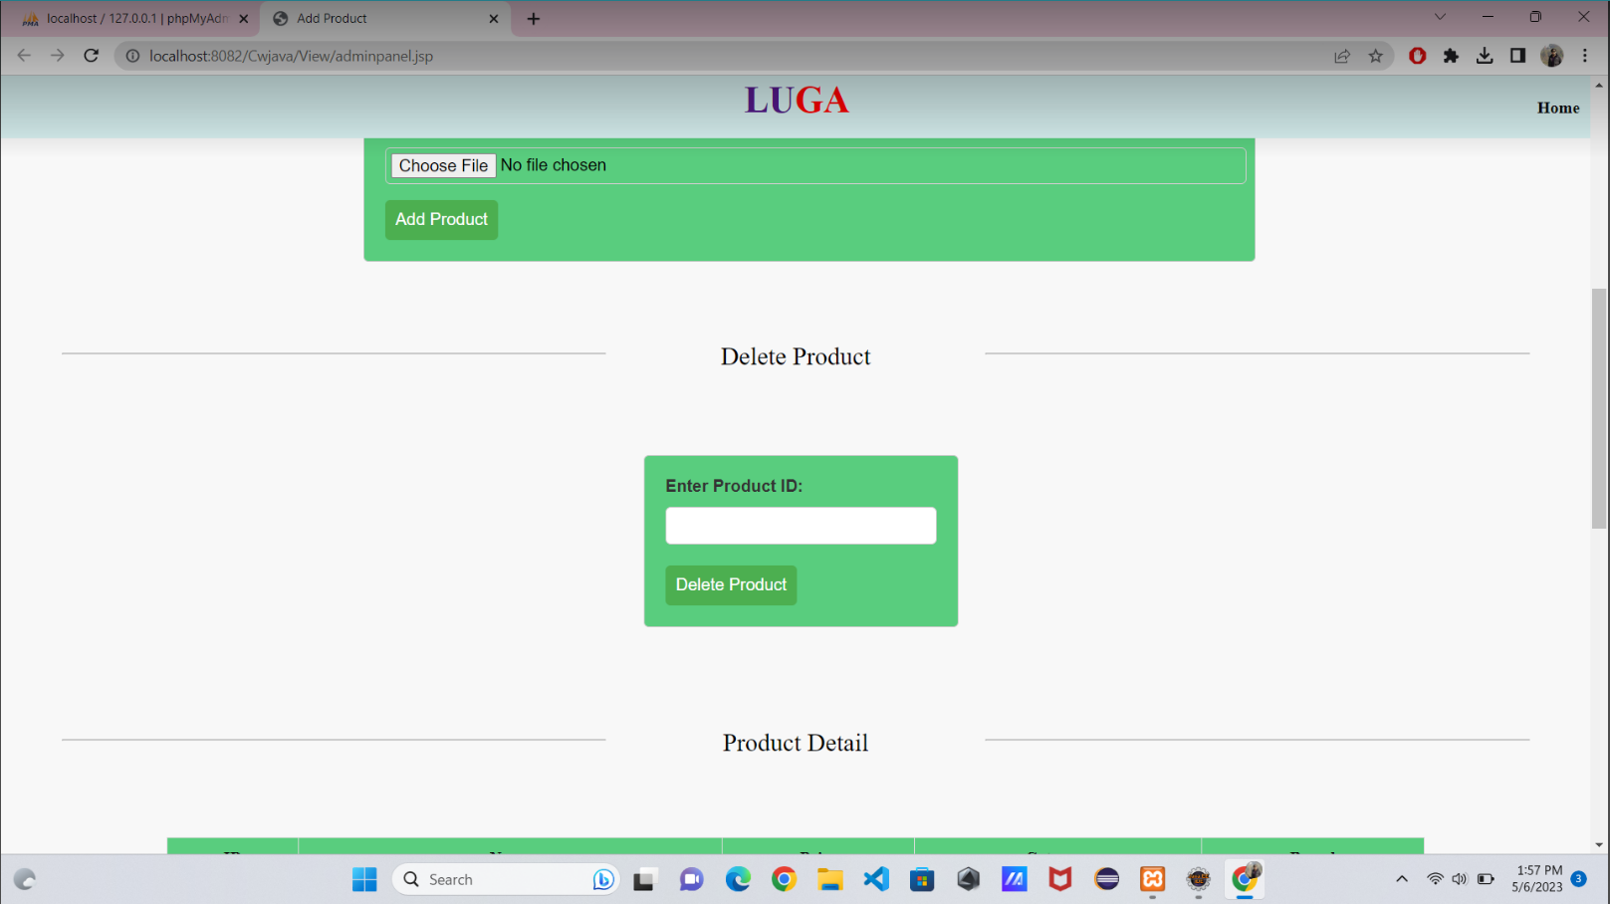

Figure 18 Delete product

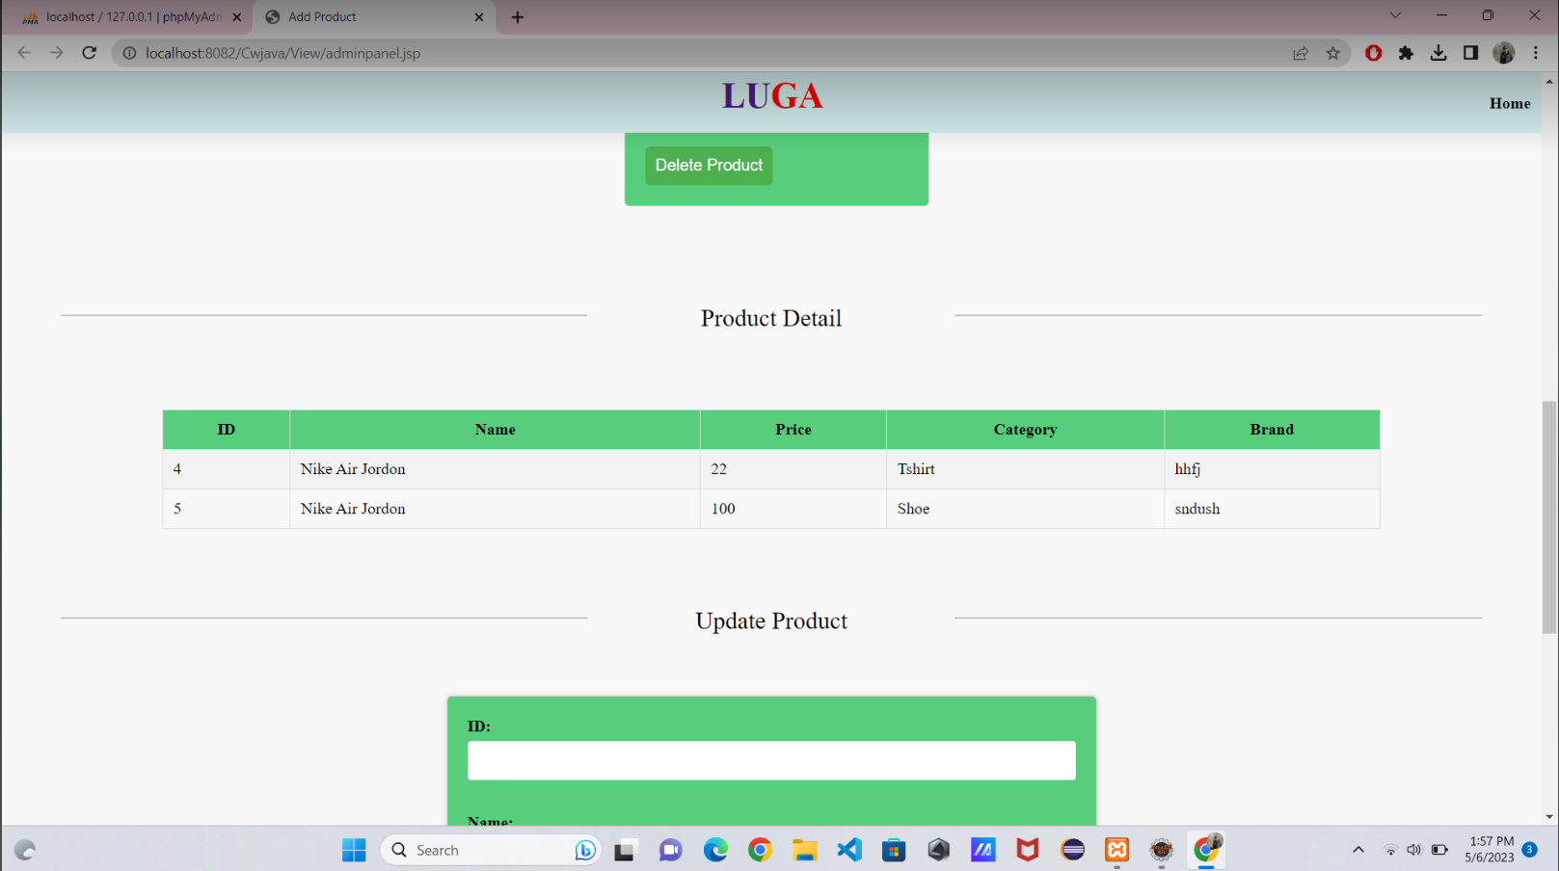

Figure 19: Show Product-Detail

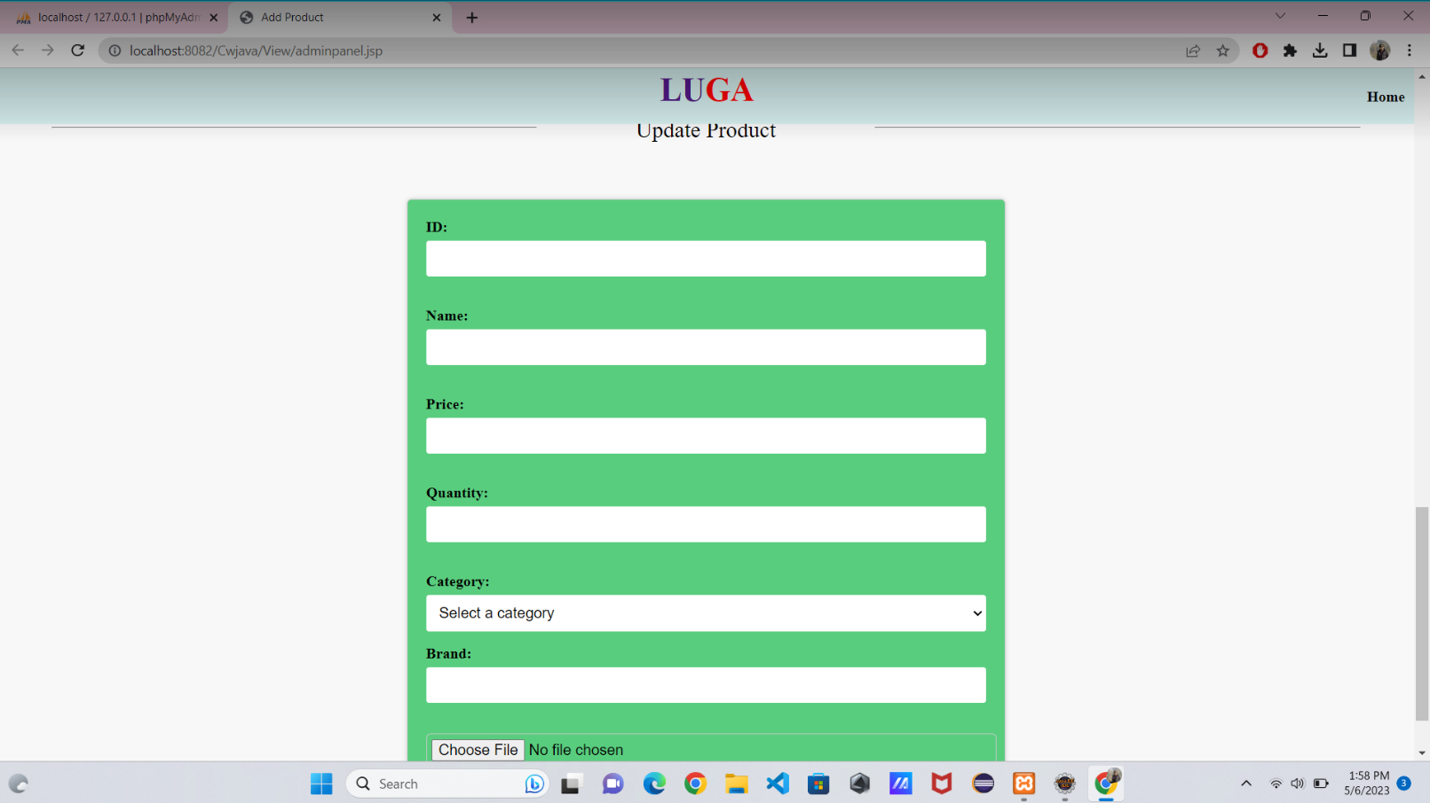

Figure 20: Update Product

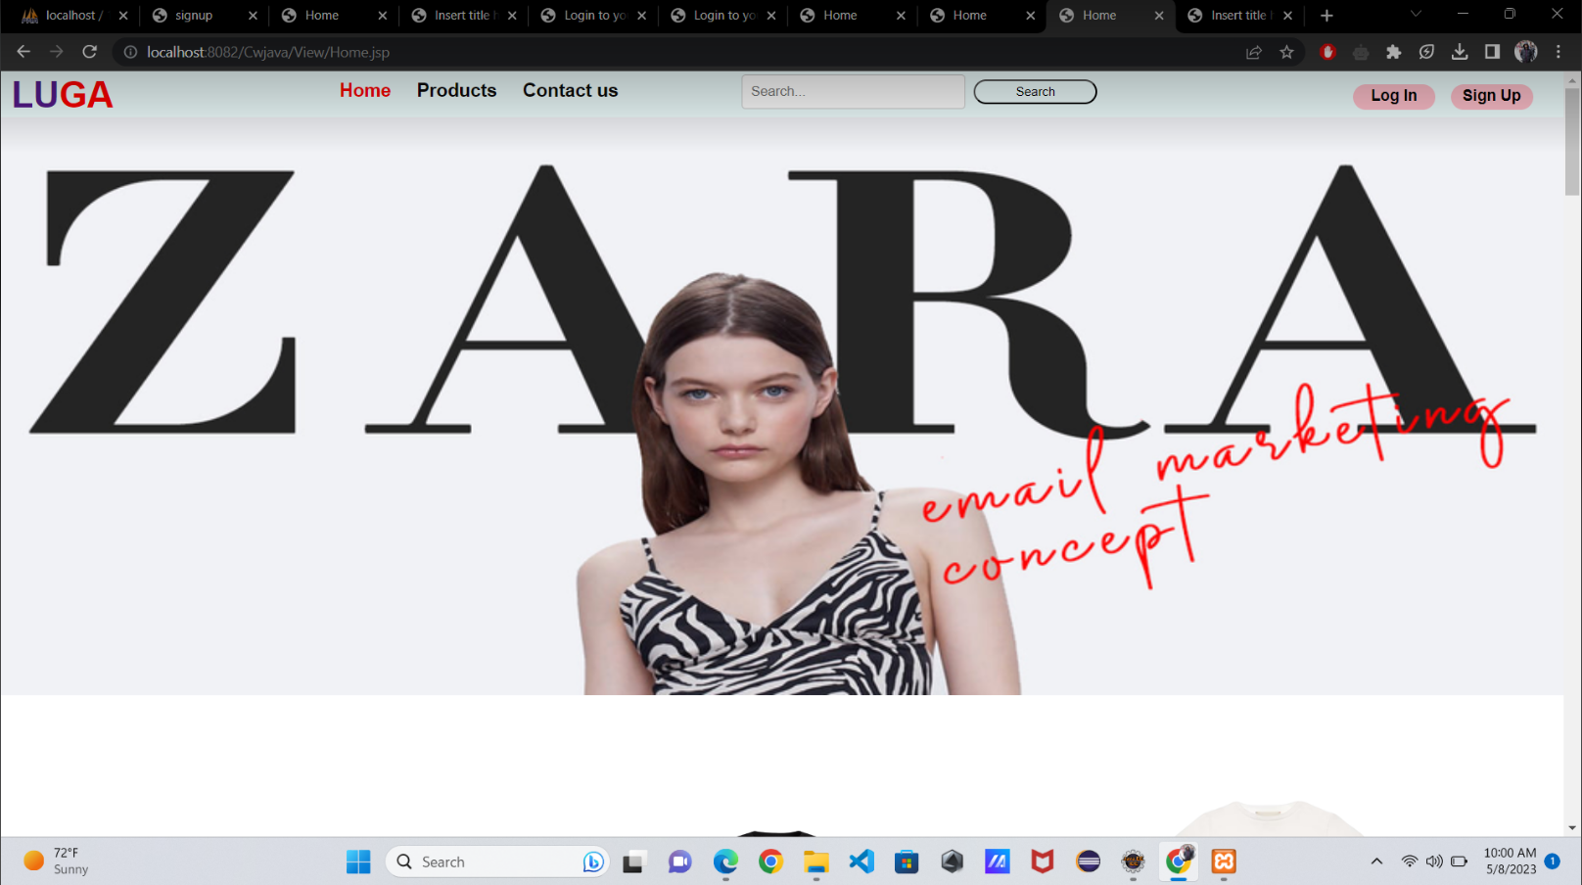

Figure 21: Home Page

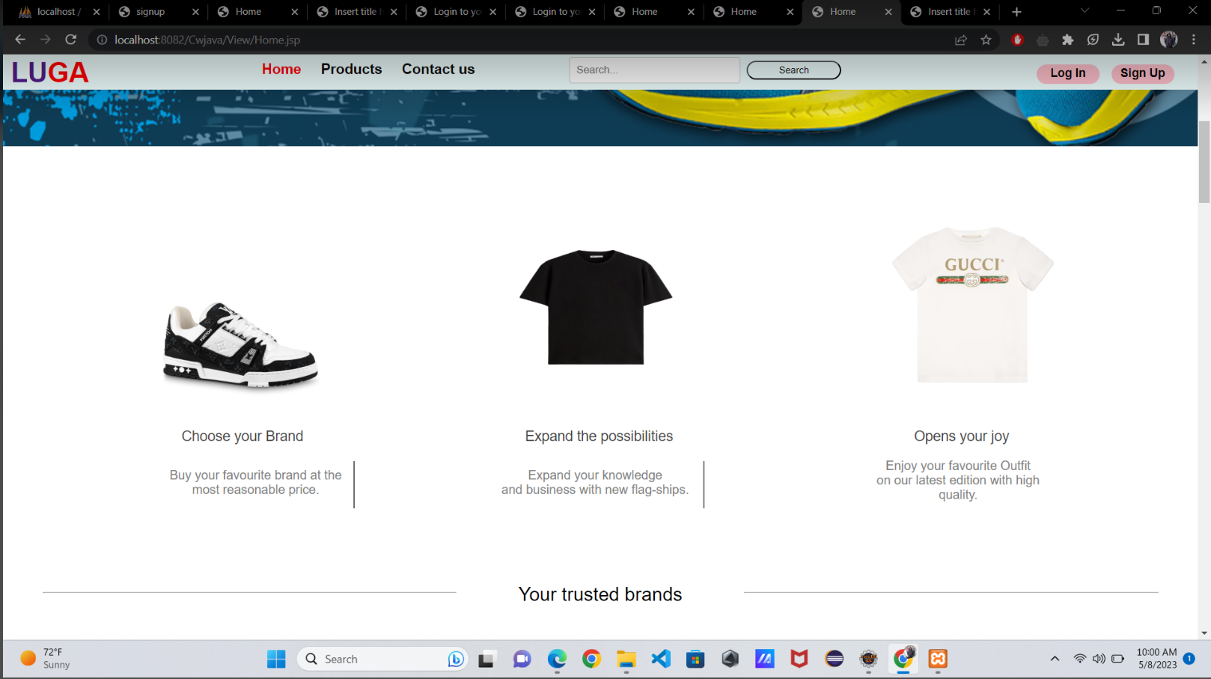

Figure 22: Home Page

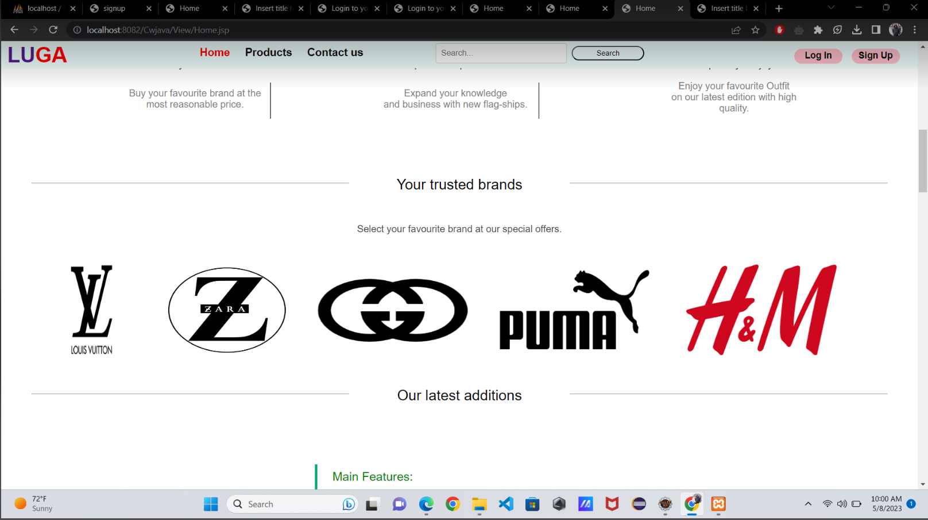

Figure 23: Home Page

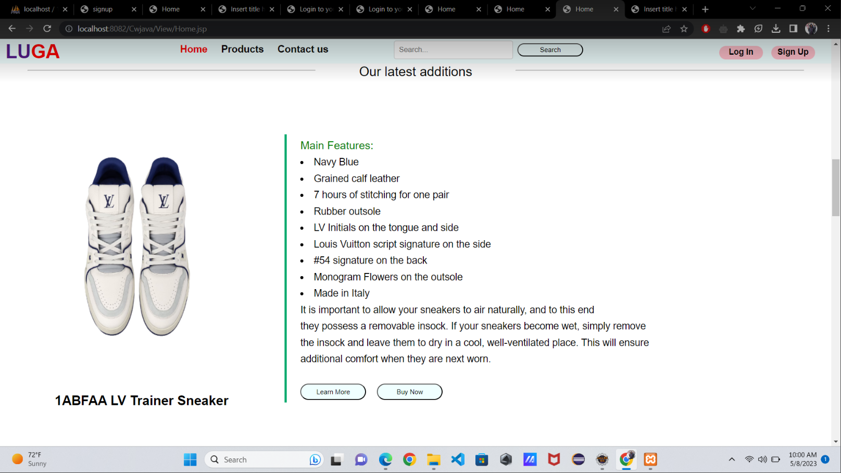

Figure 24: Home Page

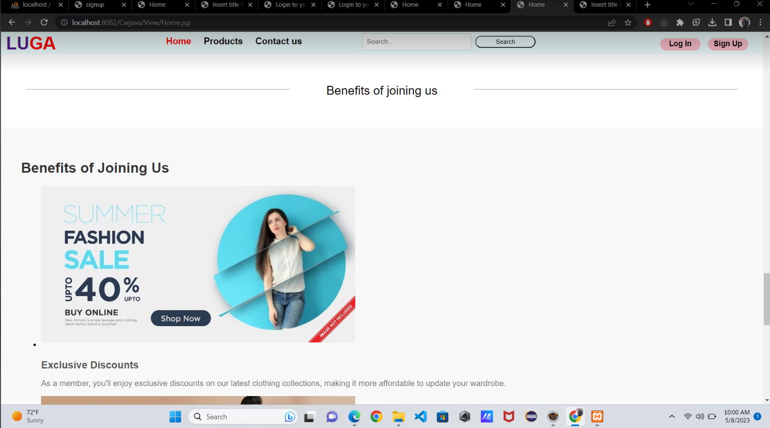

Figure 25: Home Page

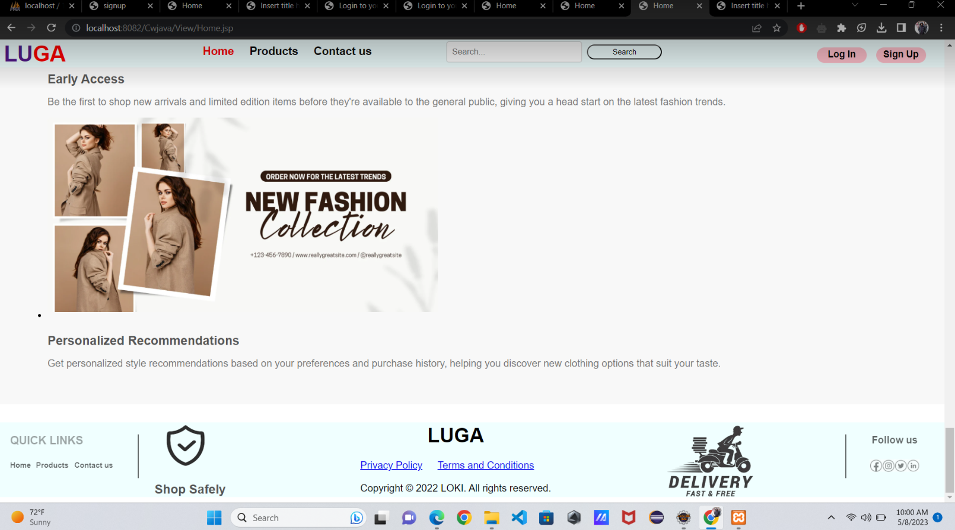

Figure 26: : Home Page

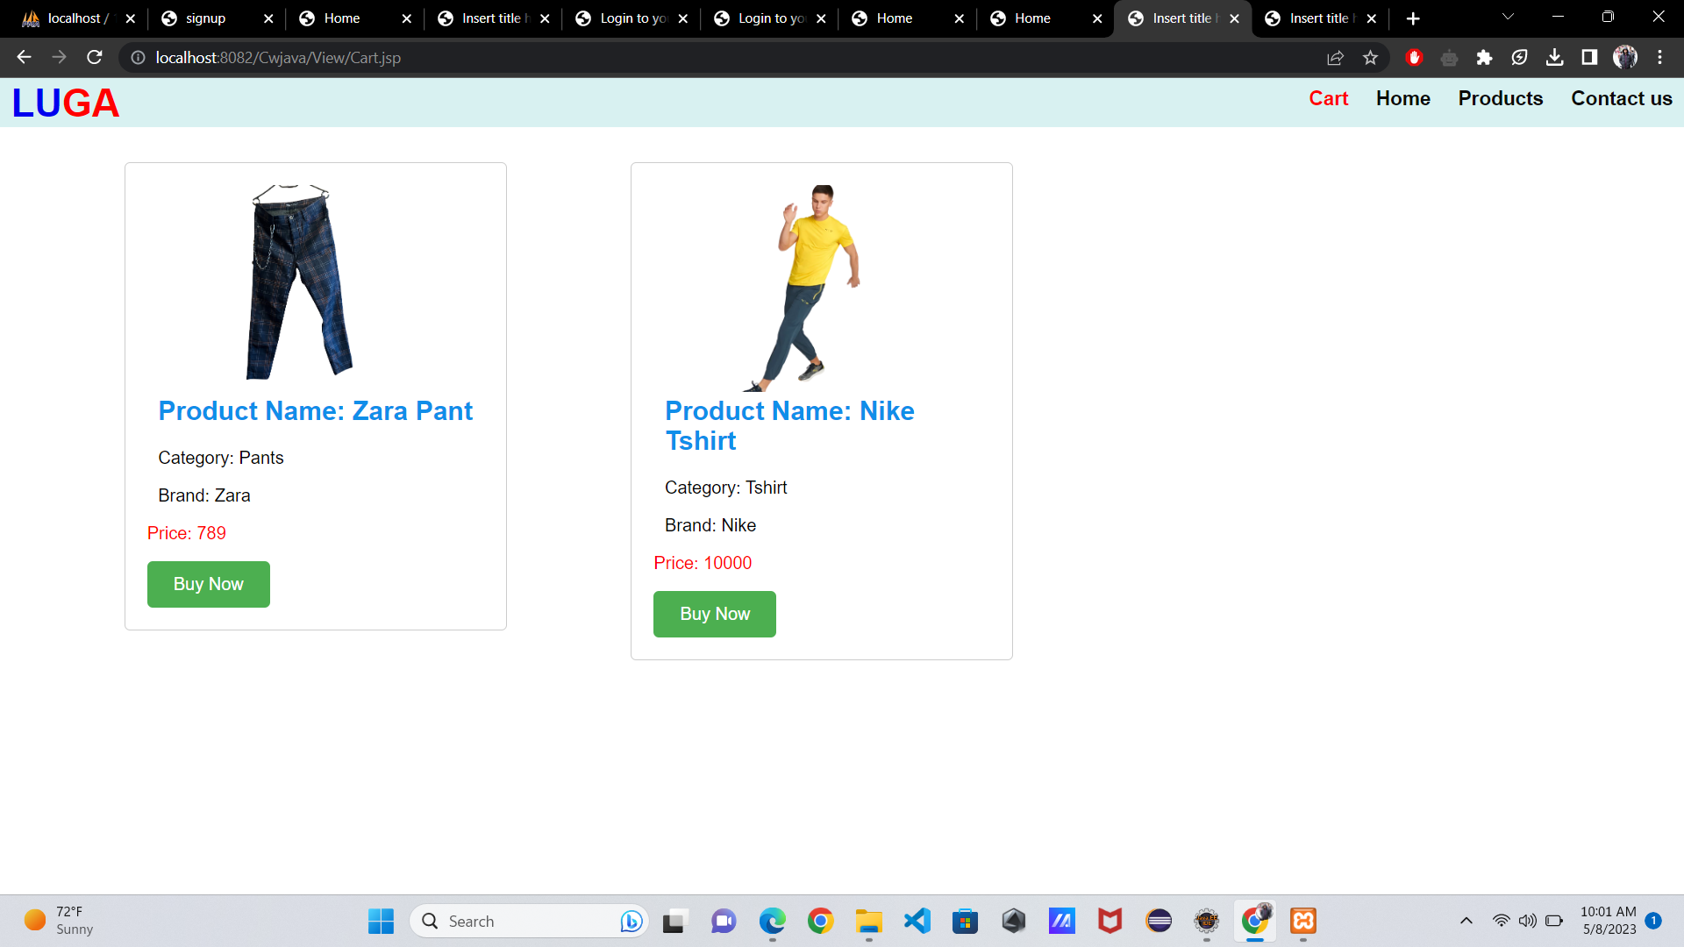

Figure 27: Cart Page

# Class diagram

A class diagram is a type of diagram and part of a unified modelling language (UML) that defines and provides the overview and structure of a system in terms of classes, attributes and methods, and the relationships between different classes (techtarget, 2018).

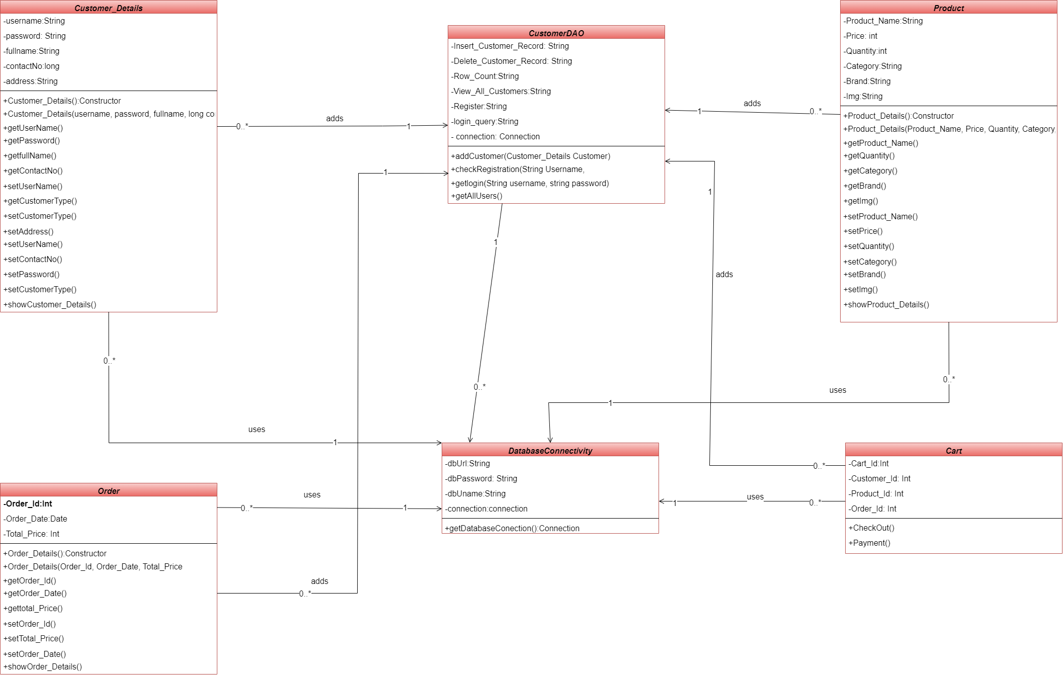

Figure 28: Class Diagra

# Method Description

## 4.1. For Customer_Details Class:

**getUserName():** This method of Customer_Details class is a getter method. This method returns UserName of the customer.

**getPassword():** This method of Customer_Details class is a getter method. This method returns Password of the customer.

**getFullName():** This method of Customer_Details class is a getter method. This method returns FullName of the customer.

**GetContactNo():** This method of Customer_Detail class is a getter method. This method returns ContactNo of the customer.

**GetCustomerType():** This method of Customer_Detail class is a getter method. This method returns CustomerType of the customer.

**SetAddress():** This method of Customer_Detail class is a setter method. This method takes address as parameter and sets it in the Address variable.

**SetUserName():** This method of Customer_Detail class is a setter method. This method takes UserName as parameter and sets it in the UserName variable.

**SetCustomerType():** This method of Customer_Detail class is a setter method. This method takes CustomerType as parameter and sets it in the CustomerType variable.

**SetPassword():** This method of Customer_Detail class is a setter method. This method takes Password as parameter and sets it in the Password variable.

**SetContactNo():** This method of Customer_Detail class is a setter method. This method takes ContactNo as parameter and sets it in the ContactNo variable.

**ShowCustomerDetails():** This method displays all the customer_details.

## 4.2. For CustomerDAO Class:

**AddCustomer():** This method adds new customers to the database.

**CheckRegistration():** This method checks if the username customer is entering is already taken or not.

**GetLogin():** This method validates the login details.

**GetAllUsers():** This method retrieves all the user details in form of objects.

**UpdateCustomer():** This method lets customer update their profile information.

**DeleteCustomer():** This method lets customer delete their details.

**Decrypt():** This method decrypts the password.

## 4.3. For DatabaseConnectivity Class:

**GetDatabaseConnectivity():** In this method, we make connection to the database using mysql connector and this method returns an object of Connection.

## 4.4. For Product Class:

**GetProductName():** This method of Product class is a getter method. This method returns ProductName of the customer.

**GetPrice():** This method of Product class is a getter method. This method returns Price of the customer.

**GetQuantity():** This method of Product class is a getter method. This method returns Quantity of the customer.

**GetCategory():** This method of Product class is a getter method. This method returns Category of the customer.

**GetBrand():** This method of Product class is a getter method. This method returns Brand of the customer.

**GetImg():** This method of Product class is a getter method. This method returns Img of the customer.

**SetProductName():** This method of Product class is a setter method. This method takes ProductName as parameter and set it in ProductName variable.

**SetPrice():** This method of Product class is a setter method. This method takes Price as parameter and set it in Price variable.

**SetQuantity():** This method of Product class is a setter method. This method takes Quantity as parameter and set it in Quantity variable.

**SetCategory():** This method of Product class is a setter method. This method takes Category as parameter and set it in Category variable.

**SetBrand():** This method of Product class is a setter method. This method takes Brandas parameter and set it in Brand variable.

**SetImg():** This method of Product class is a setter method. This method takes Image name as parameter and set it in Image variable.

4.4. For Cart Class:

**CheckOut():** In this method, the customer can select items that they want to check out and can buy them. Once CheckedOut this will update the product details in the database.

**Payment():** After Check Out request is made, the user will make payment.

## 4.5. For Order Class:

**GetOrderId():** This method of Order class is a getter method. This method returns OrderId of the customer.

**GetOrderDate():** This method of Order class is a getter method. This method returns OrderDate of the customer.

**GetTotalPrice():** This method of Order class is a getter method. This method returns TotalPrice of the customer.

**SetOrderId():** This method of Order class is a setter method. This method takes OrderId parameter and set it in OrderId variable.

**SetOrderDate():** This method of Order class is a setter method. This method takes OrderDate parameter and set it in OrderDate variable.

**SetTotalPrice():** This method of Order class is a setter method. This method takes TotalPrice parameter and set it in TotalPrice variable.

# Test cases

## Register user

|  |  |
| --- | --- |
| Test No: | 1 |
| Objective: | Register user in website |
| Action: | * User input their personal information like name, address, contact, username and password. * User upload their image. * At last User click the register button. |
| Expected Result: | The user should be successfully register in to the website. |
| Actual Result: | The user had successfully register in to the website. |
| Test: | The testing was successful. |

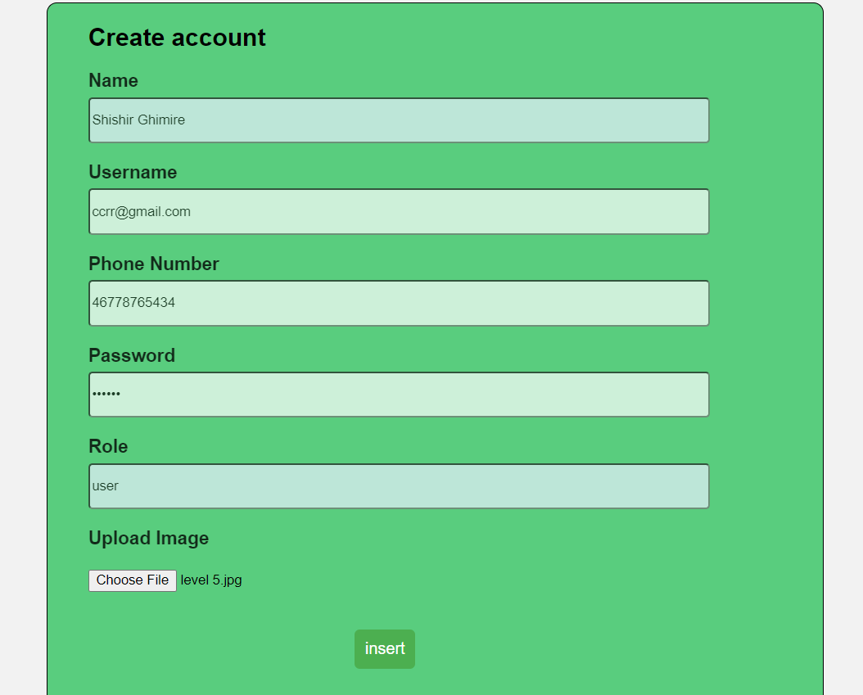s

Figure 29: Register UI

## Login to the website

|  |  |
| --- | --- |
| Test No: | 2 |
| Objective: | Login user in website |
| Action: | * User input their username and password. * At last user click login button. |
| Expected Result: | The user should be successfully login to the website. |
| Actual Result: | The user had successfully login to the website. |
| Test: | The testing was successful. |

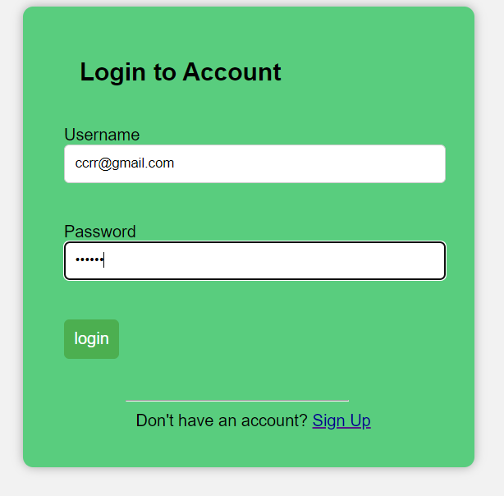

Figure 30: Login Page

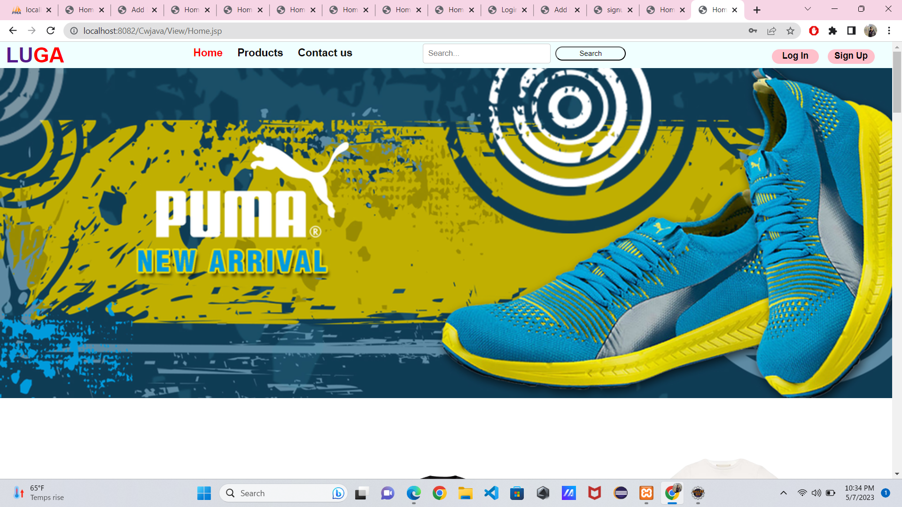

Figure 31 After logged in interface

## Add product in product page by admin

|  |  |
| --- | --- |
| Test No: | 3 |
| Objective: | Add product to product page by admin |
| Action: | * Admin give the product information like their name, price, quantity, category and brand and their images. * Click the Add product option. |
| Expected Result: | The product should be successfully added in to the product page. |
| Actual Result: | The product had successfully added in to the product page. |
| Test: | The testing was successful. |

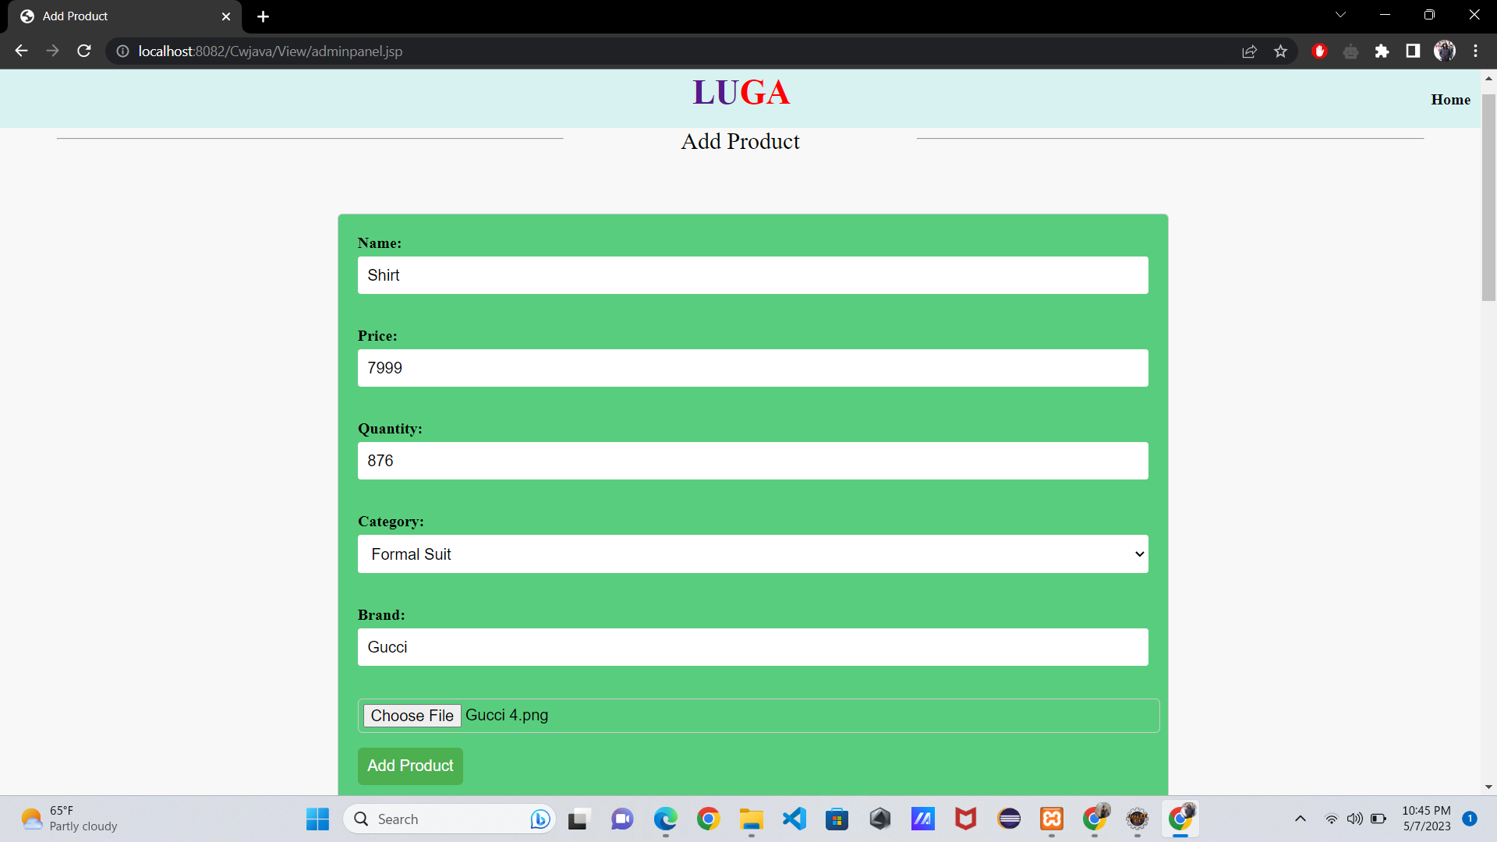

Figure 32 Add to prodcut form

Figure 33: Add to product Form

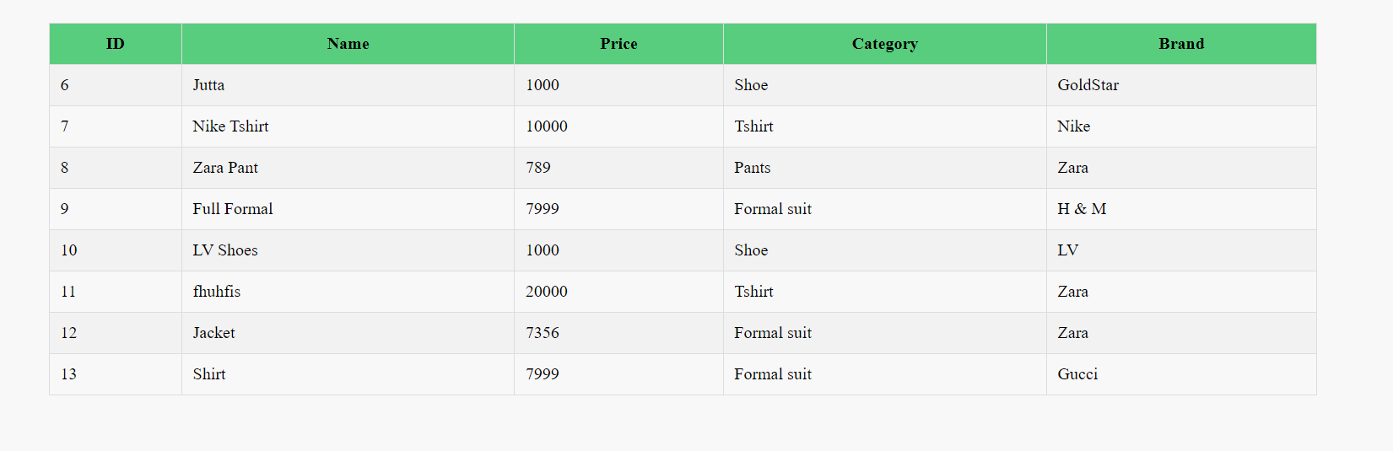

Figure 34 Store the product details which are added

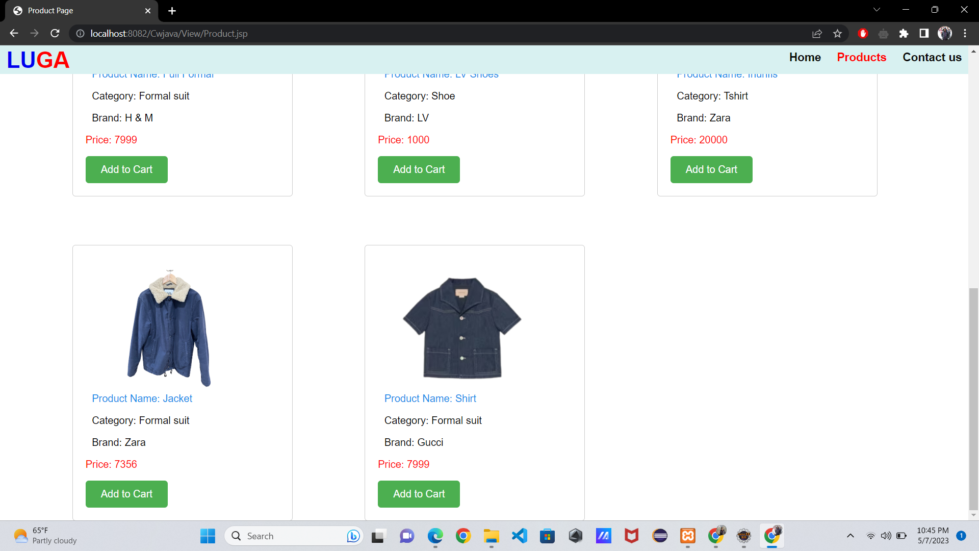

Figure 35 Product inserted

## Delete Product ID

|  |  |
| --- | --- |
| Test No: | 4 |
| Objective: | Delete product form product page by admin |
| Action: | * Admin give the details of the product like their name, price, quantity, category and brand and their images. * Click Delete Product. |
| Expected Result: | The product should be successfully added in to the product page. |
| Actual Result: | The product had successfully added in to the product page. |
| Test: | The testing was successful. |

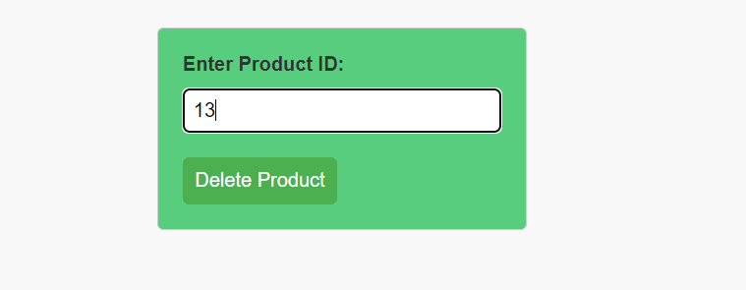

Figure 36 Entered product ID to delete



Figure 37 List of product

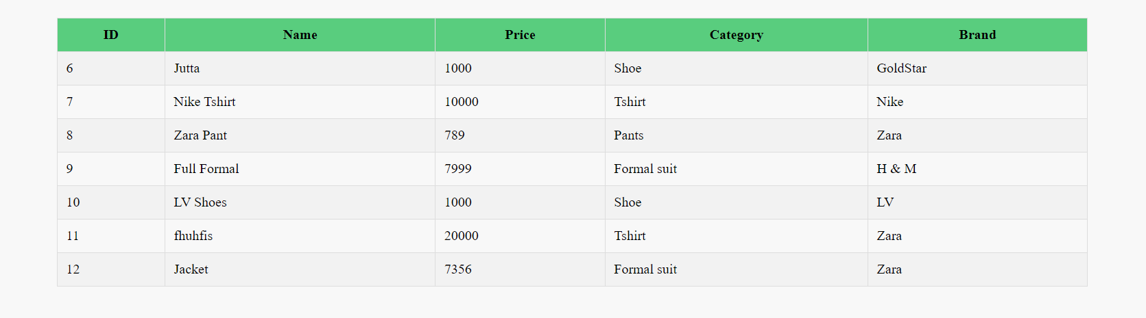

Figure 38 Product deleted

## Update Product ID

|  |  |
| --- | --- |
| Test No: | 5 |
| Objective: | Update the product from product page |
| Action: | * Admin insert the product id, name, price, quantity, brand and image to update the product * Click Update Product. |
| Expected Result: | The product should be successfully update in to the product page. |
| Actual Result: | The product had successfully update in to the product page. |
| Test: | The testing was successful. |



Figure 39 List of products with their details

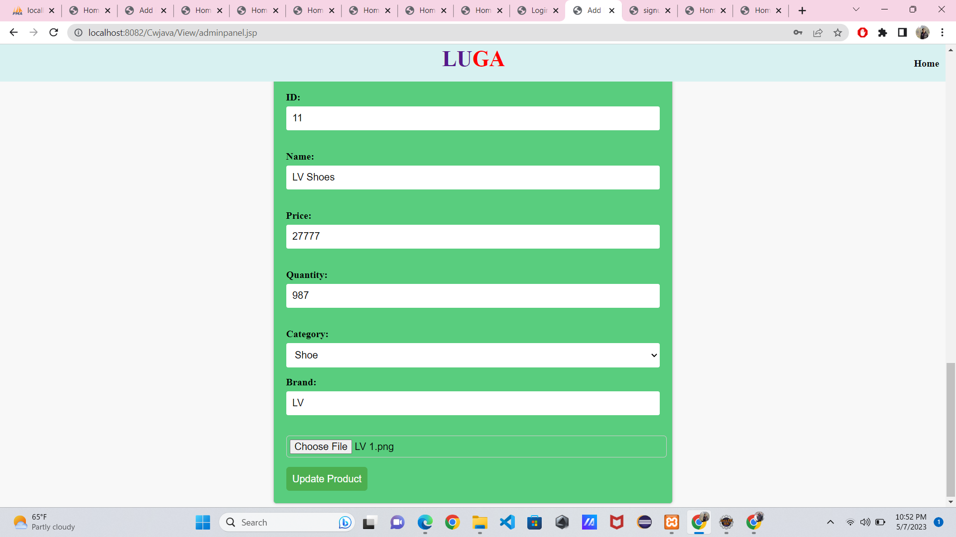

Figure 40 Updating the Product

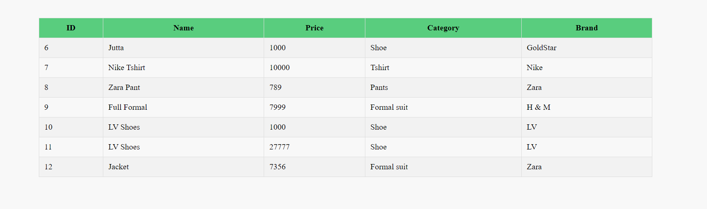

Figure 41 Finally product have been updated

## Search by Category

|  |  |
| --- | --- |
| Test No: | 6 |
| Objective: |  |
| Action: | * User search shoes |
| Expected Result: | All the available shoes should be displayed. |
| Actual Result: | All the available shoes should be displayed. |
| Test: | The testing was successful. |

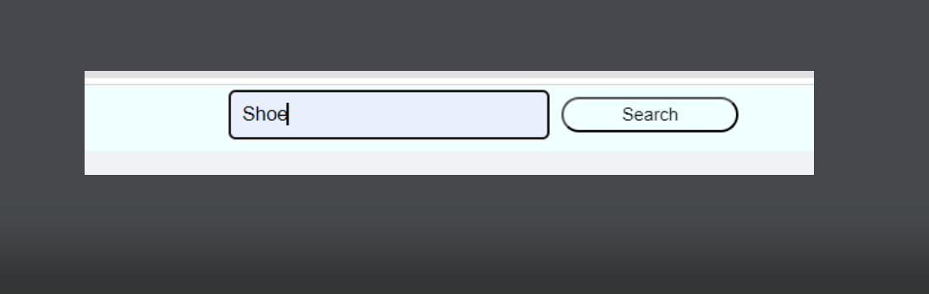

Figure 42 Searching product by name

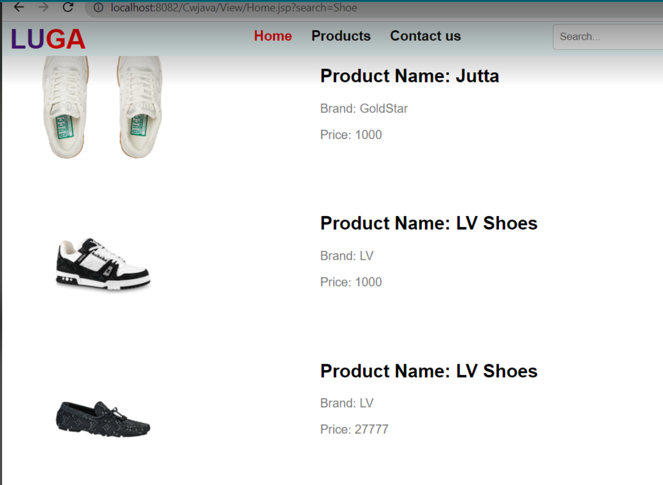

Figure 43 List of shoes

## Add to cart

|  |  |
| --- | --- |
| Test No: | 7 |
| Objective: | Product should be added on cart. |
| Action: | * User visit the product page and add the product in their cart. |
| Expected Result: | The product should be added on the cart. |
| Actual Result: | The product had been added on the cart. |
| Test: | The testing was successful. |

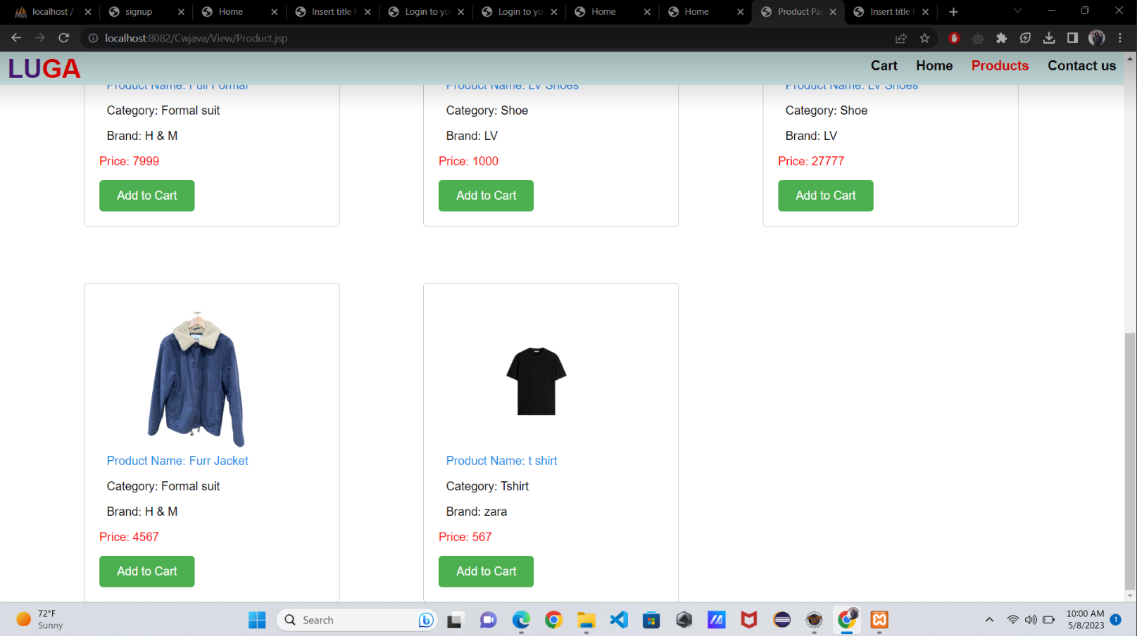

Figure 44 Product page before adding to cart

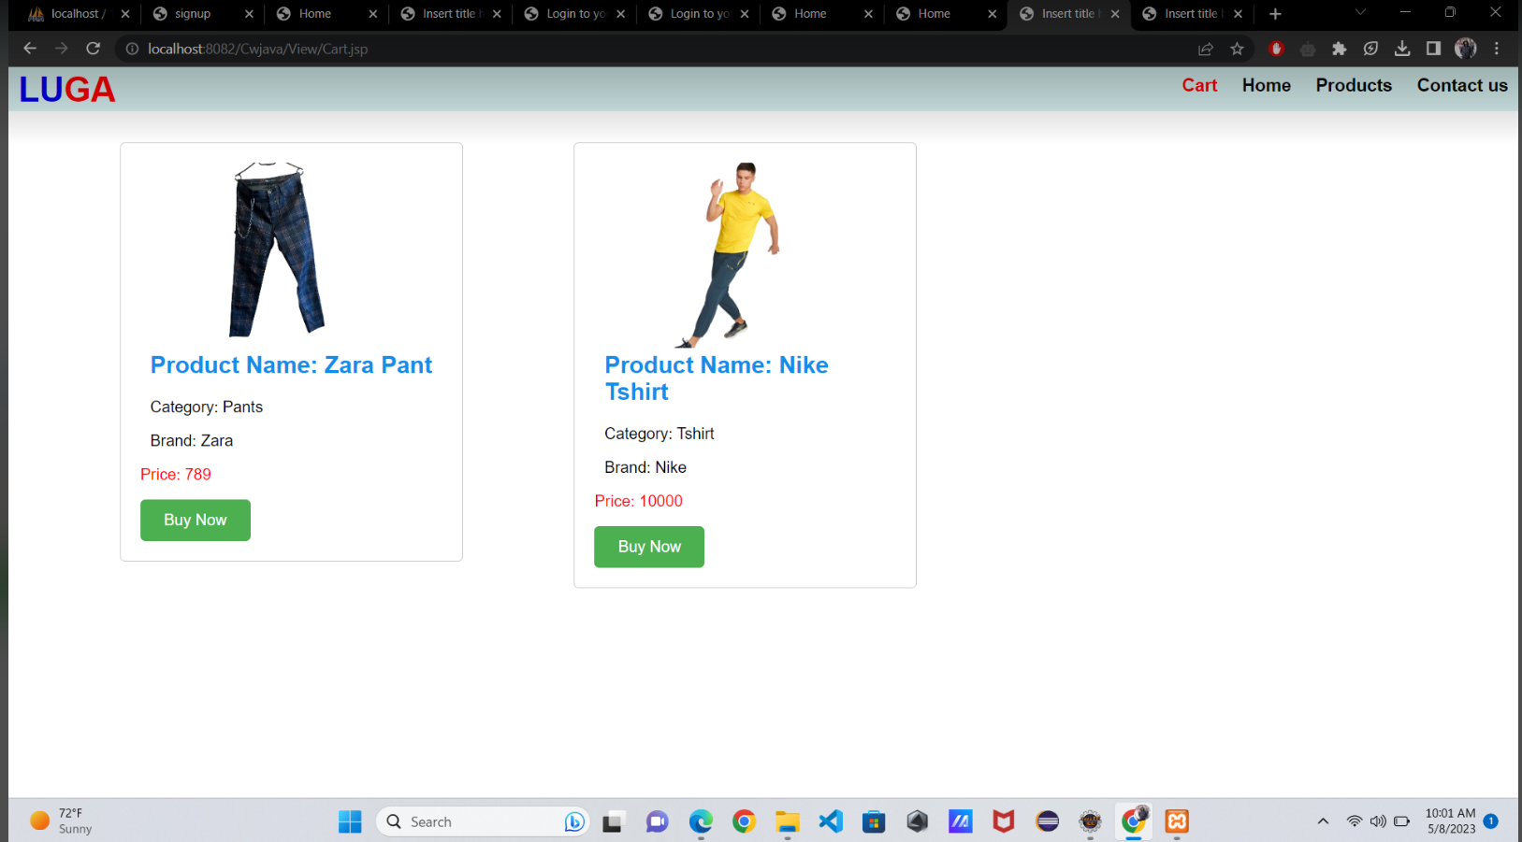

Figure 45: Added Products in Card

## Password Encryption

|  |  |
| --- | --- |
| Test No: | 8 |
| Objective: | When user registers password, it should sit in encrypted form in the database. |
| Action: | * User selects a password while registering and the password sits in encrypted form in the database. |
| Expected Result: | The password would be stored in encrypted format. |
| Actual Result: | The product is saved in encrypted format. |
| Test: | The testing was successful. |

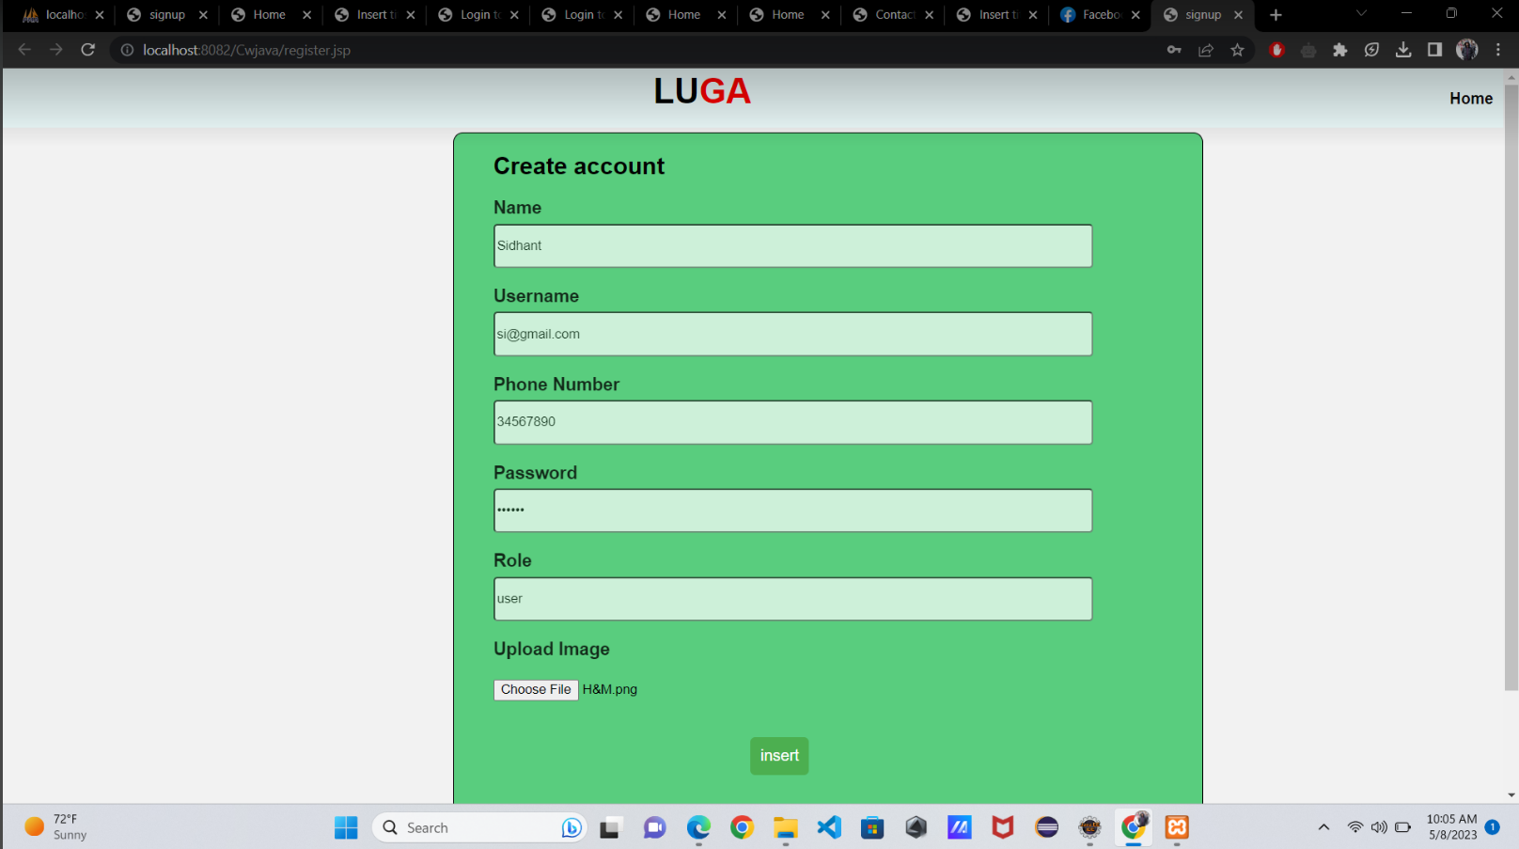

Figure 46: setting password during registration

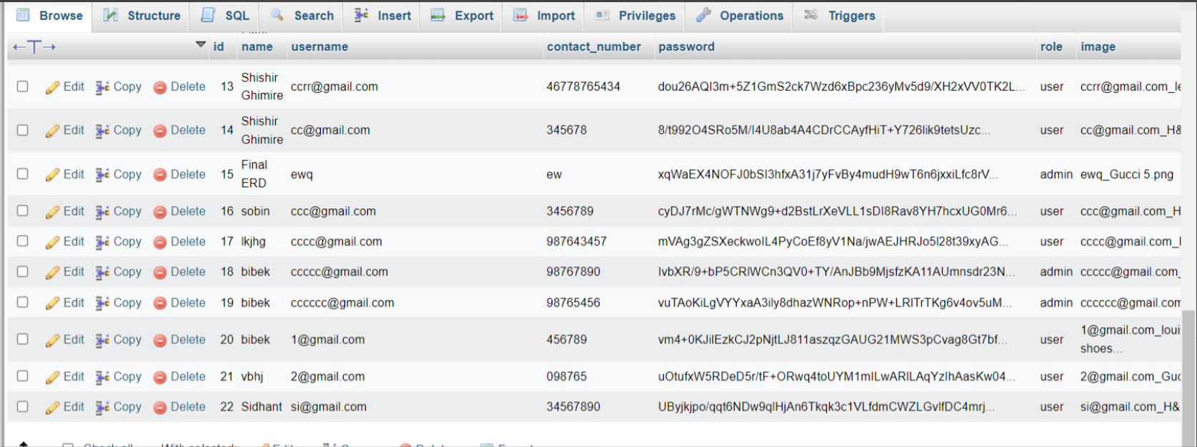

Figure 47: Encrypted Password in Database

# Tools and libraries

To complete this coursework, we have used various tools and libraries like Eclipse, XAMPP, Ms-word, Balsamiq, My SQL, and JSTL.

1. Eclipse: -

Eclipse is an extremely viewed open-source IDE that supports software development in multiple programming languages. It provides a complete set of tools and features that can be modified through plugins and extensions. Eclipse is known for its user-friendliness, powerful debugging skills, and excellent documentation. It is widely used and highly regarded among developers worldwide (wikipedia, 2015).

1. XAMPP: -

XAMPP is a free, open-source software that provides a complete web development environment with Apache, MySQL, and PHP. It is easy to install and widely used for local web application development and testing (javatpoint, 2017).

1. Ms-word: -

Microsoft Word is a user-friendly word-processing software with a range of features for formatting, collaboration, and automation. It is widely used in various organizations (ualr, 2019).

1. Balsamiq: -

Balsamiq is a GUI prototyping tool for creating user interfaces fast and intuitively. It offers pre-built UI components and collaboration features for customization and feedback, and it's widely used in software development and design, especially in Agile and Lean methodologies (balsamiq, 2018).

1. My SQL: -

MySQL is an open-source relational database management system with libraries for developers to cooperate with MySQL databases. The libraries support multiple programming interfaces, are well-documented, and offer robust features for building scalable applications. MySQL is widely used in web, e-commerce, and enterprise applications (pcmag, 2021).

1. JSTL: -

JSTL simplifies dynamic web page development in Java by providing a collection of standard tags for common tasks. It reduces the need for Java code, is platform-independent, and is widely used in enterprise web applications (digitalocean, 2022).

# Development Process

The development process for the given e-commerce website project:

1. **Feasibility Study**
2. **Pre-Project (Project Planning and Requirements):** In this initial phase, the development team planned the project's scope and defined the website's design and functionality requirements, scope, objectives, and constraints. The team created use cases and system flow diagrams (class diagrams) and established a project timeline.
3. **Foundations**
4. **Technology Selection:** Based on the project planning and requirements, the development team selected appropriate technologies and frameworks for the development of the website. We used JAVA as for programming language, Hibernate, Apache Struts as for framework, XAMPP software package for the local web server environment and for databases like MySQL.
5. **Exploration**
6. **Database Design:** Then we designed the database schema, including tables, columns, and relationships. We defined primary and foreign keys, data types, and indexes, and created sample data for testing purposes.
7. **MVC Architecture Implementation:** The team have implemented the MVC architecture and created three separate packages for model, view, and controller. We also created models for database operations and business logic, controllers for handling user requests, and views for rendering responses.
8. **User Authentication and Login:** The development team implemented a user authentication and login system that allows users to register and log in. Passwords should be encrypted and login sessions should be used.
9. **Admin Panel Implementation:** The team created an admin panel with the ability to add and manage product information, view product lists, edit and delete products, and view order lists of each customer. The admin panel is accessible only to admins.
10. **Home Page Implementation:** The development team have implemented the home page with products, images, prices, stock availability, and an "Add to Cart" option. The home page also contains a search option for users to filter products by category, price, and brand.
11. **User Account Implementation:** The team has implemented user account features, including the ability to view profiles, edit details, change passwords, view purchased or cart products, and view order lists.
12. **Validation and Exception Handling:** The team has done proper validation and exception handling mechanisms to ensure that the website is secure and error-free. An exception page is also created to display error messages.
13. **Engineering and Deployment:**
14. **Testing and Deployment:** Finally, the team thoroughly test the website to ensure that it is bug-free and fully functional.

# Critical Analysis

As part of this coursework, you will build a fully functional e-commerce website with a login system, admin panel, home page, and user account functionality. Three packages model, view, and controller - are used in the project. The controller folder contains Servlets that handle all user requests, the model folder contains database methods and model classes, and the view folder contains JSP and HTML files.

The login system requires users to register with images and encrypted passwords. Both users and admins can log in using login sessions. The admin panel is only accessible to admins and allows them to manage product information, view product lists, and edit or delete products. Clients' order lists can also be viewed. The home page displays products with images, prices, and stock availability. Users are able to filter products by category, price, and brand and add them to their cart. Also, they can view their profiles, edit their details, change their passwords, and view their order list. Proper validation and exception handling is necessary, with an exception page for error messages.

The project requirements provide an extensive list of necessary features for an e-commerce website; however, additional details on the technologies being used and a testing plan could further improve the outcome. Technologies like Spring or Hibernate would streamline the development process and make it more efficient, while a thorough testing strategy would ensure that all bugs have been dealt with prior to deployment. Taking time to consider these aspects of the project can ensure its

# Conclusion

This Coursework required us to build an Ecommerce Website (Java Dynamic Web Project). Throughout the coursework, we learned about different Libraries and tools. We learned about the various stages of Dynamic Web Project development, including requirements gathering, design, coding, testing, and maintenance.

The coursework was a good experience for us. During the coursework, we encountered numerous challenges and confusion. However, with the continuous guidance and support of our module leaders, Tutors and Group friends, we were able to overcome these problems and reduce the difficulty of the project. The lessons that (MVC) model view controller pattern.

# Bibliography

balsamiq, 2018. [Online]   
Available at: https://balsamiq.com/wireframes/cloud/docs/intro/  
[Accessed 07 05 2023].

digitalocean, 2022. [Online]   
Available at: https://www.digitalocean.com/community/tutorials/jstl-tutorial-jstl-tags-example  
[Accessed 07 05 2023].

javatpoint, 2017. [Online]   
Available at: https://www.javatpoint.com/xampp  
[Accessed 07 05 2023].

pcmag, 2021. [Online]   
Available at: https://www.pcmag.com/encyclopedia/term/msql  
[Accessed 07 05 2023].

techtarget, 2018. [Online]   
Available at: https://www.techtarget.com/searchapparchitecture/definition/user-interface-UI  
[Accessed 07 05 2023].

ualr, 2019. [Online]   
Available at: https://ualr.edu/itservices/applications/v/microsoft-word/  
[Accessed 07 05 2023].

wikipedia, 2015. [Online]   
Available at: https://en.wikipedia.org/wiki/Eclipse_(software)  
[Accessed 07 05 2023].

*.*